Exploratory Data Analysis USING AN REGRESSION –

DATASET:

|  |  |  |  |  |  |  |
| --- | --- | --- | --- | --- | --- | --- |
| age | sex | bmi | children | smoker | region | charges |
| 19 | female | 27.9 | 0 | yes | southwest | 16884.92 |
| 18 | male | 33.77 | 1 | no | southeast | 1725.552 |
| 28 | male | 33 | 3 | no | southeast | 4449.462 |
| 33 | male | 22.705 | 0 | no | northwest | 21984.47 |
| 32 | male | 28.88 | 0 | no | northwest | 3866.855 |
| 31 | female | 25.74 | 0 | no | southeast | 3756.622 |
| 46 | female | 33.44 | 1 | no | southeast | 8240.59 |
| 37 | female | 27.74 | 3 | no | northwest | 7281.506 |
| 37 | male | 29.83 | 2 | no | northeast | 6406.411 |
| 60 | female | 25.84 | 0 | no | northwest | 28923.14 |
| 25 | male | 26.22 | 0 | no | northeast | 2721.321 |
| 62 | female | 26.29 | 0 | yes | southeast | 27808.73 |
| 23 | male | 34.4 | 0 | no | southwest | 1826.843 |
| 56 | female | 39.82 | 0 | no | southeast | 11090.72 |
| 27 | male | 42.13 | 0 | yes | southeast | 39611.76 |
| 19 | male | 24.6 | 1 | no | southwest | 1837.237 |
| 52 | female | 30.78 | 1 | no | northeast | 10797.34 |
| 23 | male | 23.845 | 0 | no | northeast | 2395.172 |
| 56 | male | 40.3 | 0 | no | southwest | 10602.39 |
| 30 | male | 35.3 | 0 | yes | southwest | 36837.47 |
| 60 | female | 36.005 | 0 | no | northeast | 13228.85 |
| 30 | female | 32.4 | 1 | no | southwest | 4149.736 |
| 18 | male | 34.1 | 0 | no | southeast | 1137.011 |
| 34 | female | 31.92 | 1 | yes | northeast | 37701.88 |
| 37 | male | 28.025 | 2 | no | northwest | 6203.902 |
| 59 | female | 27.72 | 3 | no | southeast | 14001.13 |
| 63 | female | 23.085 | 0 | no | northeast | 14451.84 |
| 55 | female | 32.775 | 2 | no | northwest | 12268.63 |
| 23 | male | 17.385 | 1 | no | northwest | 2775.192 |
| 31 | male | 36.3 | 2 | yes | southwest | 38711 |
| 22 | male | 35.6 | 0 | yes | southwest | 35585.58 |
| 18 | female | 26.315 | 0 | no | northeast | 2198.19 |
| 19 | female | 28.6 | 5 | no | southwest | 4687.797 |
| 63 | male | 28.31 | 0 | no | northwest | 13770.1 |
| 28 | male | 36.4 | 1 | yes | southwest | 51194.56 |
| 19 | male | 20.425 | 0 | no | northwest | 1625.434 |
| 62 | female | 32.965 | 3 | no | northwest | 15612.19 |
| 26 | male | 20.8 | 0 | no | southwest | 2302.3 |
| 35 | male | 36.67 | 1 | yes | northeast | 39774.28 |
| 60 | male | 39.9 | 0 | yes | southwest | 48173.36 |
| 24 | female | 26.6 | 0 | no | northeast | 3046.062 |
| 31 | female | 36.63 | 2 | no | southeast | 4949.759 |
| 41 | male | 21.78 | 1 | no | southeast | 6272.477 |
| 37 | female | 30.8 | 2 | no | southeast | 6313.759 |
| 38 | male | 37.05 | 1 | no | northeast | 6079.672 |
| 55 | male | 37.3 | 0 | no | southwest | 20630.28 |
| 18 | female | 38.665 | 2 | no | northeast | 3393.356 |
| 28 | female | 34.77 | 0 | no | northwest | 3556.922 |
| 60 | female | 24.53 | 0 | no | southeast | 12629.9 |
| 36 | male | 35.2 | 1 | yes | southeast | 38709.18 |
| 18 | female | 35.625 | 0 | no | northeast | 2211.131 |
| 21 | female | 33.63 | 2 | no | northwest | 3579.829 |
| 48 | male | 28 | 1 | yes | southwest | 23568.27 |
| 36 | male | 34.43 | 0 | yes | southeast | 37742.58 |
| 40 | female | 28.69 | 3 | no | northwest | 8059.679 |
| 58 | male | 36.955 | 2 | yes | northwest | 47496.49 |
| 58 | female | 31.825 | 2 | no | northeast | 13607.37 |
| 18 | male | 31.68 | 2 | yes | southeast | 34303.17 |
| 53 | female | 22.88 | 1 | yes | southeast | 23244.79 |
| 34 | female | 37.335 | 2 | no | northwest | 5989.524 |
| 43 | male | 27.36 | 3 | no | northeast | 8606.217 |
| 25 | male | 33.66 | 4 | no | southeast | 4504.662 |
| 64 | male | 24.7 | 1 | no | northwest | 30166.62 |
| 28 | female | 25.935 | 1 | no | northwest | 4133.642 |
| 20 | female | 22.42 | 0 | yes | northwest | 14711.74 |
| 19 | female | 28.9 | 0 | no | southwest | 1743.214 |
| 61 | female | 39.1 | 2 | no | southwest | 14235.07 |
| 40 | male | 26.315 | 1 | no | northwest | 6389.378 |
| 40 | female | 36.19 | 0 | no | southeast | 5920.104 |
| 28 | male | 23.98 | 3 | yes | southeast | 17663.14 |
| 27 | female | 24.75 | 0 | yes | southeast | 16577.78 |
| 31 | male | 28.5 | 5 | no | northeast | 6799.458 |
| 53 | female | 28.1 | 3 | no | southwest | 11741.73 |
| 58 | male | 32.01 | 1 | no | southeast | 11946.63 |
| 44 | male | 27.4 | 2 | no | southwest | 7726.854 |
| 57 | male | 34.01 | 0 | no | northwest | 11356.66 |
| 29 | female | 29.59 | 1 | no | southeast | 3947.413 |
| 21 | male | 35.53 | 0 | no | southeast | 1532.47 |
| 22 | female | 39.805 | 0 | no | northeast | 2755.021 |
| 41 | female | 32.965 | 0 | no | northwest | 6571.024 |
| 31 | male | 26.885 | 1 | no | northeast | 4441.213 |
| 45 | female | 38.285 | 0 | no | northeast | 7935.291 |
| 22 | male | 37.62 | 1 | yes | southeast | 37165.16 |
| 48 | female | 41.23 | 4 | no | northwest | 11033.66 |
| 37 | female | 34.8 | 2 | yes | southwest | 39836.52 |
| 45 | male | 22.895 | 2 | yes | northwest | 21098.55 |
| 57 | female | 31.16 | 0 | yes | northwest | 43578.94 |
| 56 | female | 27.2 | 0 | no | southwest | 11073.18 |
| 46 | female | 27.74 | 0 | no | northwest | 8026.667 |
| 55 | female | 26.98 | 0 | no | northwest | 11082.58 |
| 21 | female | 39.49 | 0 | no | southeast | 2026.974 |
| 53 | female | 24.795 | 1 | no | northwest | 10942.13 |
| 59 | male | 29.83 | 3 | yes | northeast | 30184.94 |
| 35 | male | 34.77 | 2 | no | northwest | 5729.005 |
| 64 | female | 31.3 | 2 | yes | southwest | 47291.06 |
| 28 | female | 37.62 | 1 | no | southeast | 3766.884 |
| 54 | female | 30.8 | 3 | no | southwest | 12105.32 |
| 55 | male | 38.28 | 0 | no | southeast | 10226.28 |
| 56 | male | 19.95 | 0 | yes | northeast | 22412.65 |
| 38 | male | 19.3 | 0 | yes | southwest | 15820.7 |
| 41 | female | 31.6 | 0 | no | southwest | 6186.127 |
| 30 | male | 25.46 | 0 | no | northeast | 3645.089 |
| 18 | female | 30.115 | 0 | no | northeast | 21344.85 |
| 61 | female | 29.92 | 3 | yes | southeast | 30942.19 |
| 34 | female | 27.5 | 1 | no | southwest | 5003.853 |
| 20 | male | 28.025 | 1 | yes | northwest | 17560.38 |
| 19 | female | 28.4 | 1 | no | southwest | 2331.519 |
| 26 | male | 30.875 | 2 | no | northwest | 3877.304 |
| 29 | male | 27.94 | 0 | no | southeast | 2867.12 |
| 63 | male | 35.09 | 0 | yes | southeast | 47055.53 |
| 54 | male | 33.63 | 1 | no | northwest | 10825.25 |
| 55 | female | 29.7 | 2 | no | southwest | 11881.36 |
| 37 | male | 30.8 | 0 | no | southwest | 4646.759 |
| 21 | female | 35.72 | 0 | no | northwest | 2404.734 |
| 52 | male | 32.205 | 3 | no | northeast | 11488.32 |
| 60 | male | 28.595 | 0 | no | northeast | 30260 |
| 58 | male | 49.06 | 0 | no | southeast | 11381.33 |
| 29 | female | 27.94 | 1 | yes | southeast | 19107.78 |
| 49 | female | 27.17 | 0 | no | southeast | 8601.329 |
| 37 | female | 23.37 | 2 | no | northwest | 6686.431 |
| 44 | male | 37.1 | 2 | no | southwest | 7740.337 |
| 18 | male | 23.75 | 0 | no | northeast | 1705.625 |
| 20 | female | 28.975 | 0 | no | northwest | 2257.475 |
| 44 | male | 31.35 | 1 | yes | northeast | 39556.49 |
| 47 | female | 33.915 | 3 | no | northwest | 10115.01 |
| 26 | female | 28.785 | 0 | no | northeast | 3385.399 |
| 19 | female | 28.3 | 0 | yes | southwest | 17081.08 |
| 52 | female | 37.4 | 0 | no | southwest | 9634.538 |
| 32 | female | 17.765 | 2 | yes | northwest | 32734.19 |
| 38 | male | 34.7 | 2 | no | southwest | 6082.405 |
| 59 | female | 26.505 | 0 | no | northeast | 12815.44 |
| 61 | female | 22.04 | 0 | no | northeast | 13616.36 |
| 53 | female | 35.9 | 2 | no | southwest | 11163.57 |
| 19 | male | 25.555 | 0 | no | northwest | 1632.564 |
| 20 | female | 28.785 | 0 | no | northeast | 2457.211 |
| 22 | female | 28.05 | 0 | no | southeast | 2155.682 |
| 19 | male | 34.1 | 0 | no | southwest | 1261.442 |
| 22 | male | 25.175 | 0 | no | northwest | 2045.685 |
| 54 | female | 31.9 | 3 | no | southeast | 27322.73 |
| 22 | female | 36 | 0 | no | southwest | 2166.732 |
| 34 | male | 22.42 | 2 | no | northeast | 27375.9 |
| 26 | male | 32.49 | 1 | no | northeast | 3490.549 |
| 34 | male | 25.3 | 2 | yes | southeast | 18972.5 |
| 29 | male | 29.735 | 2 | no | northwest | 18157.88 |
| 30 | male | 28.69 | 3 | yes | northwest | 20745.99 |
| 29 | female | 38.83 | 3 | no | southeast | 5138.257 |
| 46 | male | 30.495 | 3 | yes | northwest | 40720.55 |
| 51 | female | 37.73 | 1 | no | southeast | 9877.608 |
| 53 | female | 37.43 | 1 | no | northwest | 10959.69 |
| 19 | male | 28.4 | 1 | no | southwest | 1842.519 |
| 35 | male | 24.13 | 1 | no | northwest | 5125.216 |
| 48 | male | 29.7 | 0 | no | southeast | 7789.635 |
| 32 | female | 37.145 | 3 | no | northeast | 6334.344 |
| 42 | female | 23.37 | 0 | yes | northeast | 19964.75 |
| 40 | female | 25.46 | 1 | no | northeast | 7077.189 |
| 44 | male | 39.52 | 0 | no | northwest | 6948.701 |
| 48 | male | 24.42 | 0 | yes | southeast | 21223.68 |
| 18 | male | 25.175 | 0 | yes | northeast | 15518.18 |
| 30 | male | 35.53 | 0 | yes | southeast | 36950.26 |
| 50 | female | 27.83 | 3 | no | southeast | 19749.38 |
| 42 | female | 26.6 | 0 | yes | northwest | 21348.71 |
| 18 | female | 36.85 | 0 | yes | southeast | 36149.48 |
| 54 | male | 39.6 | 1 | no | southwest | 10450.55 |
| 32 | female | 29.8 | 2 | no | southwest | 5152.134 |
| 37 | male | 29.64 | 0 | no | northwest | 5028.147 |
| 47 | male | 28.215 | 4 | no | northeast | 10407.09 |
| 20 | female | 37 | 5 | no | southwest | 4830.63 |
| 32 | female | 33.155 | 3 | no | northwest | 6128.797 |
| 19 | female | 31.825 | 1 | no | northwest | 2719.28 |
| 27 | male | 18.905 | 3 | no | northeast | 4827.905 |
| 63 | male | 41.47 | 0 | no | southeast | 13405.39 |
| 49 | male | 30.3 | 0 | no | southwest | 8116.68 |
| 18 | male | 15.96 | 0 | no | northeast | 1694.796 |
| 35 | female | 34.8 | 1 | no | southwest | 5246.047 |
| 24 | female | 33.345 | 0 | no | northwest | 2855.438 |
| 63 | female | 37.7 | 0 | yes | southwest | 48824.45 |
| 38 | male | 27.835 | 2 | no | northwest | 6455.863 |
| 54 | male | 29.2 | 1 | no | southwest | 10436.1 |
| 46 | female | 28.9 | 2 | no | southwest | 8823.279 |
| 41 | female | 33.155 | 3 | no | northeast | 8538.288 |
| 58 | male | 28.595 | 0 | no | northwest | 11735.88 |
| 18 | female | 38.28 | 0 | no | southeast | 1631.821 |
| 22 | male | 19.95 | 3 | no | northeast | 4005.423 |
| 44 | female | 26.41 | 0 | no | northwest | 7419.478 |
| 44 | male | 30.69 | 2 | no | southeast | 7731.427 |
| 36 | male | 41.895 | 3 | yes | northeast | 43753.34 |
| 26 | female | 29.92 | 2 | no | southeast | 3981.977 |
| 30 | female | 30.9 | 3 | no | southwest | 5325.651 |
| 41 | female | 32.2 | 1 | no | southwest | 6775.961 |
| 29 | female | 32.11 | 2 | no | northwest | 4922.916 |
| 61 | male | 31.57 | 0 | no | southeast | 12557.61 |
| 36 | female | 26.2 | 0 | no | southwest | 4883.866 |
| 25 | male | 25.74 | 0 | no | southeast | 2137.654 |
| 56 | female | 26.6 | 1 | no | northwest | 12044.34 |
| 18 | male | 34.43 | 0 | no | southeast | 1137.47 |
| 19 | male | 30.59 | 0 | no | northwest | 1639.563 |
| 39 | female | 32.8 | 0 | no | southwest | 5649.715 |
| 45 | female | 28.6 | 2 | no | southeast | 8516.829 |
| 51 | female | 18.05 | 0 | no | northwest | 9644.253 |
| 64 | female | 39.33 | 0 | no | northeast | 14901.52 |
| 19 | female | 32.11 | 0 | no | northwest | 2130.676 |
| 48 | female | 32.23 | 1 | no | southeast | 8871.152 |
| 60 | female | 24.035 | 0 | no | northwest | 13012.21 |
| 27 | female | 36.08 | 0 | yes | southeast | 37133.9 |
| 46 | male | 22.3 | 0 | no | southwest | 7147.105 |
| 28 | female | 28.88 | 1 | no | northeast | 4337.735 |
| 59 | male | 26.4 | 0 | no | southeast | 11743.3 |
| 35 | male | 27.74 | 2 | yes | northeast | 20984.09 |
| 63 | female | 31.8 | 0 | no | southwest | 13880.95 |
| 40 | male | 41.23 | 1 | no | northeast | 6610.11 |
| 20 | male | 33 | 1 | no | southwest | 1980.07 |
| 40 | male | 30.875 | 4 | no | northwest | 8162.716 |
| 24 | male | 28.5 | 2 | no | northwest | 3537.703 |
| 34 | female | 26.73 | 1 | no | southeast | 5002.783 |
| 45 | female | 30.9 | 2 | no | southwest | 8520.026 |
| 41 | female | 37.1 | 2 | no | southwest | 7371.772 |
| 53 | female | 26.6 | 0 | no | northwest | 10355.64 |
| 27 | male | 23.1 | 0 | no | southeast | 2483.736 |
| 26 | female | 29.92 | 1 | no | southeast | 3392.977 |
| 24 | female | 23.21 | 0 | no | southeast | 25081.77 |
| 34 | female | 33.7 | 1 | no | southwest | 5012.471 |
| 53 | female | 33.25 | 0 | no | northeast | 10564.88 |
| 32 | male | 30.8 | 3 | no | southwest | 5253.524 |
| 19 | male | 34.8 | 0 | yes | southwest | 34779.62 |
| 42 | male | 24.64 | 0 | yes | southeast | 19515.54 |
| 55 | male | 33.88 | 3 | no | southeast | 11987.17 |
| 28 | male | 38.06 | 0 | no | southeast | 2689.495 |
| 58 | female | 41.91 | 0 | no | southeast | 24227.34 |
| 41 | female | 31.635 | 1 | no | northeast | 7358.176 |
| 47 | male | 25.46 | 2 | no | northeast | 9225.256 |
| 42 | female | 36.195 | 1 | no | northwest | 7443.643 |
| 59 | female | 27.83 | 3 | no | southeast | 14001.29 |
| 19 | female | 17.8 | 0 | no | southwest | 1727.785 |
| 59 | male | 27.5 | 1 | no | southwest | 12333.83 |
| 39 | male | 24.51 | 2 | no | northwest | 6710.192 |
| 40 | female | 22.22 | 2 | yes | southeast | 19444.27 |
| 18 | female | 26.73 | 0 | no | southeast | 1615.767 |
| 31 | male | 38.39 | 2 | no | southeast | 4463.205 |
| 19 | male | 29.07 | 0 | yes | northwest | 17352.68 |
| 44 | male | 38.06 | 1 | no | southeast | 7152.671 |
| 23 | female | 36.67 | 2 | yes | northeast | 38511.63 |
| 33 | female | 22.135 | 1 | no | northeast | 5354.075 |
| 55 | female | 26.8 | 1 | no | southwest | 35160.13 |
| 40 | male | 35.3 | 3 | no | southwest | 7196.867 |
| 63 | female | 27.74 | 0 | yes | northeast | 29523.17 |
| 54 | male | 30.02 | 0 | no | northwest | 24476.48 |
| 60 | female | 38.06 | 0 | no | southeast | 12648.7 |
| 24 | male | 35.86 | 0 | no | southeast | 1986.933 |
| 19 | male | 20.9 | 1 | no | southwest | 1832.094 |
| 29 | male | 28.975 | 1 | no | northeast | 4040.558 |
| 18 | male | 17.29 | 2 | yes | northeast | 12829.46 |
| 63 | female | 32.2 | 2 | yes | southwest | 47305.31 |
| 54 | male | 34.21 | 2 | yes | southeast | 44260.75 |
| 27 | male | 30.3 | 3 | no | southwest | 4260.744 |
| 50 | male | 31.825 | 0 | yes | northeast | 41097.16 |
| 55 | female | 25.365 | 3 | no | northeast | 13047.33 |
| 56 | male | 33.63 | 0 | yes | northwest | 43921.18 |
| 38 | female | 40.15 | 0 | no | southeast | 5400.981 |
| 51 | male | 24.415 | 4 | no | northwest | 11520.1 |
| 19 | male | 31.92 | 0 | yes | northwest | 33750.29 |
| 58 | female | 25.2 | 0 | no | southwest | 11837.16 |
| 20 | female | 26.84 | 1 | yes | southeast | 17085.27 |
| 52 | male | 24.32 | 3 | yes | northeast | 24869.84 |
| 19 | male | 36.955 | 0 | yes | northwest | 36219.41 |
| 53 | female | 38.06 | 3 | no | southeast | 20463 |
| 46 | male | 42.35 | 3 | yes | southeast | 46151.12 |
| 40 | male | 19.8 | 1 | yes | southeast | 17179.52 |
| 59 | female | 32.395 | 3 | no | northeast | 14590.63 |
| 45 | male | 30.2 | 1 | no | southwest | 7441.053 |
| 49 | male | 25.84 | 1 | no | northeast | 9282.481 |
| 18 | male | 29.37 | 1 | no | southeast | 1719.436 |
| 50 | male | 34.2 | 2 | yes | southwest | 42856.84 |
| 41 | male | 37.05 | 2 | no | northwest | 7265.703 |
| 50 | male | 27.455 | 1 | no | northeast | 9617.662 |
| 25 | male | 27.55 | 0 | no | northwest | 2523.17 |
| 47 | female | 26.6 | 2 | no | northeast | 9715.841 |
| 19 | male | 20.615 | 2 | no | northwest | 2803.698 |
| 22 | female | 24.3 | 0 | no | southwest | 2150.469 |
| 59 | male | 31.79 | 2 | no | southeast | 12928.79 |
| 51 | female | 21.56 | 1 | no | southeast | 9855.131 |
| 40 | female | 28.12 | 1 | yes | northeast | 22331.57 |
| 54 | male | 40.565 | 3 | yes | northeast | 48549.18 |
| 30 | male | 27.645 | 1 | no | northeast | 4237.127 |
| 55 | female | 32.395 | 1 | no | northeast | 11879.1 |
| 52 | female | 31.2 | 0 | no | southwest | 9625.92 |
| 46 | male | 26.62 | 1 | no | southeast | 7742.11 |
| 46 | female | 48.07 | 2 | no | northeast | 9432.925 |
| 63 | female | 26.22 | 0 | no | northwest | 14256.19 |
| 59 | female | 36.765 | 1 | yes | northeast | 47896.79 |
| 52 | male | 26.4 | 3 | no | southeast | 25992.82 |
| 28 | female | 33.4 | 0 | no | southwest | 3172.018 |
| 29 | male | 29.64 | 1 | no | northeast | 20277.81 |
| 25 | male | 45.54 | 2 | yes | southeast | 42112.24 |
| 22 | female | 28.82 | 0 | no | southeast | 2156.752 |
| 25 | male | 26.8 | 3 | no | southwest | 3906.127 |
| 18 | male | 22.99 | 0 | no | northeast | 1704.568 |
| 19 | male | 27.7 | 0 | yes | southwest | 16297.85 |
| 47 | male | 25.41 | 1 | yes | southeast | 21978.68 |
| 31 | male | 34.39 | 3 | yes | northwest | 38746.36 |
| 48 | female | 28.88 | 1 | no | northwest | 9249.495 |
| 36 | male | 27.55 | 3 | no | northeast | 6746.743 |
| 53 | female | 22.61 | 3 | yes | northeast | 24873.38 |
| 56 | female | 37.51 | 2 | no | southeast | 12265.51 |
| 28 | female | 33 | 2 | no | southeast | 4349.462 |
| 57 | female | 38 | 2 | no | southwest | 12646.21 |
| 29 | male | 33.345 | 2 | no | northwest | 19442.35 |
| 28 | female | 27.5 | 2 | no | southwest | 20177.67 |
| 30 | female | 33.33 | 1 | no | southeast | 4151.029 |
| 58 | male | 34.865 | 0 | no | northeast | 11944.59 |
| 41 | female | 33.06 | 2 | no | northwest | 7749.156 |
| 50 | male | 26.6 | 0 | no | southwest | 8444.474 |
| 19 | female | 24.7 | 0 | no | southwest | 1737.376 |
| 43 | male | 35.97 | 3 | yes | southeast | 42124.52 |
| 49 | male | 35.86 | 0 | no | southeast | 8124.408 |
| 27 | female | 31.4 | 0 | yes | southwest | 34838.87 |
| 52 | male | 33.25 | 0 | no | northeast | 9722.77 |
| 50 | male | 32.205 | 0 | no | northwest | 8835.265 |
| 54 | male | 32.775 | 0 | no | northeast | 10435.07 |
| 44 | female | 27.645 | 0 | no | northwest | 7421.195 |
| 32 | male | 37.335 | 1 | no | northeast | 4667.608 |
| 34 | male | 25.27 | 1 | no | northwest | 4894.753 |
| 26 | female | 29.64 | 4 | no | northeast | 24671.66 |
| 34 | male | 30.8 | 0 | yes | southwest | 35491.64 |
| 57 | male | 40.945 | 0 | no | northeast | 11566.3 |
| 29 | male | 27.2 | 0 | no | southwest | 2866.091 |
| 40 | male | 34.105 | 1 | no | northeast | 6600.206 |
| 27 | female | 23.21 | 1 | no | southeast | 3561.889 |
| 45 | male | 36.48 | 2 | yes | northwest | 42760.5 |
| 64 | female | 33.8 | 1 | yes | southwest | 47928.03 |
| 52 | male | 36.7 | 0 | no | southwest | 9144.565 |
| 61 | female | 36.385 | 1 | yes | northeast | 48517.56 |
| 52 | male | 27.36 | 0 | yes | northwest | 24393.62 |
| 61 | female | 31.16 | 0 | no | northwest | 13429.04 |
| 56 | female | 28.785 | 0 | no | northeast | 11658.38 |
| 43 | female | 35.72 | 2 | no | northeast | 19144.58 |
| 64 | male | 34.5 | 0 | no | southwest | 13822.8 |
| 60 | male | 25.74 | 0 | no | southeast | 12142.58 |
| 62 | male | 27.55 | 1 | no | northwest | 13937.67 |
| 50 | male | 32.3 | 1 | yes | northeast | 41919.1 |
| 46 | female | 27.72 | 1 | no | southeast | 8232.639 |
| 24 | female | 27.6 | 0 | no | southwest | 18955.22 |
| 62 | male | 30.02 | 0 | no | northwest | 13352.1 |
| 60 | female | 27.55 | 0 | no | northeast | 13217.09 |
| 63 | male | 36.765 | 0 | no | northeast | 13981.85 |
| 49 | female | 41.47 | 4 | no | southeast | 10977.21 |
| 34 | female | 29.26 | 3 | no | southeast | 6184.299 |
| 33 | male | 35.75 | 2 | no | southeast | 4890 |
| 46 | male | 33.345 | 1 | no | northeast | 8334.458 |
| 36 | female | 29.92 | 1 | no | southeast | 5478.037 |
| 19 | male | 27.835 | 0 | no | northwest | 1635.734 |
| 57 | female | 23.18 | 0 | no | northwest | 11830.61 |
| 50 | female | 25.6 | 0 | no | southwest | 8932.084 |
| 30 | female | 27.7 | 0 | no | southwest | 3554.203 |
| 33 | male | 35.245 | 0 | no | northeast | 12404.88 |
| 18 | female | 38.28 | 0 | no | southeast | 14133.04 |
| 46 | male | 27.6 | 0 | no | southwest | 24603.05 |
| 46 | male | 43.89 | 3 | no | southeast | 8944.115 |
| 47 | male | 29.83 | 3 | no | northwest | 9620.331 |
| 23 | male | 41.91 | 0 | no | southeast | 1837.282 |
| 18 | female | 20.79 | 0 | no | southeast | 1607.51 |
| 48 | female | 32.3 | 2 | no | northeast | 10043.25 |
| 35 | male | 30.5 | 1 | no | southwest | 4751.07 |
| 19 | female | 21.7 | 0 | yes | southwest | 13844.51 |
| 21 | female | 26.4 | 1 | no | southwest | 2597.779 |
| 21 | female | 21.89 | 2 | no | southeast | 3180.51 |
| 49 | female | 30.78 | 1 | no | northeast | 9778.347 |
| 56 | female | 32.3 | 3 | no | northeast | 13430.27 |
| 42 | female | 24.985 | 2 | no | northwest | 8017.061 |
| 44 | male | 32.015 | 2 | no | northwest | 8116.269 |
| 18 | male | 30.4 | 3 | no | northeast | 3481.868 |
| 61 | female | 21.09 | 0 | no | northwest | 13415.04 |
| 57 | female | 22.23 | 0 | no | northeast | 12029.29 |
| 42 | female | 33.155 | 1 | no | northeast | 7639.417 |
| 26 | male | 32.9 | 2 | yes | southwest | 36085.22 |
| 20 | male | 33.33 | 0 | no | southeast | 1391.529 |
| 23 | female | 28.31 | 0 | yes | northwest | 18033.97 |
| 39 | female | 24.89 | 3 | yes | northeast | 21659.93 |
| 24 | male | 40.15 | 0 | yes | southeast | 38126.25 |
| 64 | female | 30.115 | 3 | no | northwest | 16455.71 |
| 62 | male | 31.46 | 1 | no | southeast | 27000.98 |
| 27 | female | 17.955 | 2 | yes | northeast | 15006.58 |
| 55 | male | 30.685 | 0 | yes | northeast | 42303.69 |
| 55 | male | 33 | 0 | no | southeast | 20781.49 |
| 35 | female | 43.34 | 2 | no | southeast | 5846.918 |
| 44 | male | 22.135 | 2 | no | northeast | 8302.536 |
| 19 | male | 34.4 | 0 | no | southwest | 1261.859 |
| 58 | female | 39.05 | 0 | no | southeast | 11856.41 |
| 50 | male | 25.365 | 2 | no | northwest | 30284.64 |
| 26 | female | 22.61 | 0 | no | northwest | 3176.816 |
| 24 | female | 30.21 | 3 | no | northwest | 4618.08 |
| 48 | male | 35.625 | 4 | no | northeast | 10736.87 |
| 19 | female | 37.43 | 0 | no | northwest | 2138.071 |
| 48 | male | 31.445 | 1 | no | northeast | 8964.061 |
| 49 | male | 31.35 | 1 | no | northeast | 9290.14 |
| 46 | female | 32.3 | 2 | no | northeast | 9411.005 |
| 46 | male | 19.855 | 0 | no | northwest | 7526.706 |
| 43 | female | 34.4 | 3 | no | southwest | 8522.003 |
| 21 | male | 31.02 | 0 | no | southeast | 16586.5 |
| 64 | male | 25.6 | 2 | no | southwest | 14988.43 |
| 18 | female | 38.17 | 0 | no | southeast | 1631.668 |
| 51 | female | 20.6 | 0 | no | southwest | 9264.797 |
| 47 | male | 47.52 | 1 | no | southeast | 8083.92 |
| 64 | female | 32.965 | 0 | no | northwest | 14692.67 |
| 49 | male | 32.3 | 3 | no | northwest | 10269.46 |
| 31 | male | 20.4 | 0 | no | southwest | 3260.199 |
| 52 | female | 38.38 | 2 | no | northeast | 11396.9 |
| 33 | female | 24.31 | 0 | no | southeast | 4185.098 |
| 47 | female | 23.6 | 1 | no | southwest | 8539.671 |
| 38 | male | 21.12 | 3 | no | southeast | 6652.529 |
| 32 | male | 30.03 | 1 | no | southeast | 4074.454 |
| 19 | male | 17.48 | 0 | no | northwest | 1621.34 |
| 44 | female | 20.235 | 1 | yes | northeast | 19594.81 |
| 26 | female | 17.195 | 2 | yes | northeast | 14455.64 |
| 25 | male | 23.9 | 5 | no | southwest | 5080.096 |
| 19 | female | 35.15 | 0 | no | northwest | 2134.902 |
| 43 | female | 35.64 | 1 | no | southeast | 7345.727 |
| 52 | male | 34.1 | 0 | no | southeast | 9140.951 |
| 36 | female | 22.6 | 2 | yes | southwest | 18608.26 |
| 64 | male | 39.16 | 1 | no | southeast | 14418.28 |
| 63 | female | 26.98 | 0 | yes | northwest | 28950.47 |
| 64 | male | 33.88 | 0 | yes | southeast | 46889.26 |
| 61 | male | 35.86 | 0 | yes | southeast | 46599.11 |
| 40 | male | 32.775 | 1 | yes | northeast | 39125.33 |
| 25 | male | 30.59 | 0 | no | northeast | 2727.395 |
| 48 | male | 30.2 | 2 | no | southwest | 8968.33 |
| 45 | male | 24.31 | 5 | no | southeast | 9788.866 |
| 38 | female | 27.265 | 1 | no | northeast | 6555.07 |
| 18 | female | 29.165 | 0 | no | northeast | 7323.735 |
| 21 | female | 16.815 | 1 | no | northeast | 3167.456 |
| 27 | female | 30.4 | 3 | no | northwest | 18804.75 |
| 19 | male | 33.1 | 0 | no | southwest | 23082.96 |
| 29 | female | 20.235 | 2 | no | northwest | 4906.41 |
| 42 | male | 26.9 | 0 | no | southwest | 5969.723 |
| 60 | female | 30.5 | 0 | no | southwest | 12638.2 |
| 31 | male | 28.595 | 1 | no | northwest | 4243.59 |
| 60 | male | 33.11 | 3 | no | southeast | 13919.82 |
| 22 | male | 31.73 | 0 | no | northeast | 2254.797 |
| 35 | male | 28.9 | 3 | no | southwest | 5926.846 |
| 52 | female | 46.75 | 5 | no | southeast | 12592.53 |
| 26 | male | 29.45 | 0 | no | northeast | 2897.324 |
| 31 | female | 32.68 | 1 | no | northwest | 4738.268 |
| 33 | female | 33.5 | 0 | yes | southwest | 37079.37 |
| 18 | male | 43.01 | 0 | no | southeast | 1149.396 |
| 59 | female | 36.52 | 1 | no | southeast | 28287.9 |
| 56 | male | 26.695 | 1 | yes | northwest | 26109.33 |
| 45 | female | 33.1 | 0 | no | southwest | 7345.084 |
| 60 | male | 29.64 | 0 | no | northeast | 12731 |
| 56 | female | 25.65 | 0 | no | northwest | 11454.02 |
| 40 | female | 29.6 | 0 | no | southwest | 5910.944 |
| 35 | male | 38.6 | 1 | no | southwest | 4762.329 |
| 39 | male | 29.6 | 4 | no | southwest | 7512.267 |
| 30 | male | 24.13 | 1 | no | northwest | 4032.241 |
| 24 | male | 23.4 | 0 | no | southwest | 1969.614 |
| 20 | male | 29.735 | 0 | no | northwest | 1769.532 |
| 32 | male | 46.53 | 2 | no | southeast | 4686.389 |
| 59 | male | 37.4 | 0 | no | southwest | 21797 |
| 55 | female | 30.14 | 2 | no | southeast | 11881.97 |
| 57 | female | 30.495 | 0 | no | northwest | 11840.78 |
| 56 | male | 39.6 | 0 | no | southwest | 10601.41 |
| 40 | female | 33 | 3 | no | southeast | 7682.67 |
| 49 | female | 36.63 | 3 | no | southeast | 10381.48 |
| 42 | male | 30 | 0 | yes | southwest | 22144.03 |
| 62 | female | 38.095 | 2 | no | northeast | 15230.32 |
| 56 | male | 25.935 | 0 | no | northeast | 11165.42 |
| 19 | male | 25.175 | 0 | no | northwest | 1632.036 |
| 30 | female | 28.38 | 1 | yes | southeast | 19521.97 |
| 60 | female | 28.7 | 1 | no | southwest | 13224.69 |
| 56 | female | 33.82 | 2 | no | northwest | 12643.38 |
| 28 | female | 24.32 | 1 | no | northeast | 23288.93 |
| 18 | female | 24.09 | 1 | no | southeast | 2201.097 |
| 27 | male | 32.67 | 0 | no | southeast | 2497.038 |
| 18 | female | 30.115 | 0 | no | northeast | 2203.472 |
| 19 | female | 29.8 | 0 | no | southwest | 1744.465 |
| 47 | female | 33.345 | 0 | no | northeast | 20878.78 |
| 54 | male | 25.1 | 3 | yes | southwest | 25382.3 |
| 61 | male | 28.31 | 1 | yes | northwest | 28868.66 |
| 24 | male | 28.5 | 0 | yes | northeast | 35147.53 |
| 25 | male | 35.625 | 0 | no | northwest | 2534.394 |
| 21 | male | 36.85 | 0 | no | southeast | 1534.305 |
| 23 | male | 32.56 | 0 | no | southeast | 1824.285 |
| 63 | male | 41.325 | 3 | no | northwest | 15555.19 |
| 49 | male | 37.51 | 2 | no | southeast | 9304.702 |
| 18 | female | 31.35 | 0 | no | southeast | 1622.189 |
| 51 | female | 39.5 | 1 | no | southwest | 9880.068 |
| 48 | male | 34.3 | 3 | no | southwest | 9563.029 |
| 31 | female | 31.065 | 0 | no | northeast | 4347.023 |
| 54 | female | 21.47 | 3 | no | northwest | 12475.35 |
| 19 | male | 28.7 | 0 | no | southwest | 1253.936 |
| 44 | female | 38.06 | 0 | yes | southeast | 48885.14 |
| 53 | male | 31.16 | 1 | no | northwest | 10461.98 |
| 19 | female | 32.9 | 0 | no | southwest | 1748.774 |
| 61 | female | 25.08 | 0 | no | southeast | 24513.09 |
| 18 | female | 25.08 | 0 | no | northeast | 2196.473 |
| 61 | male | 43.4 | 0 | no | southwest | 12574.05 |
| 21 | male | 25.7 | 4 | yes | southwest | 17942.11 |
| 20 | male | 27.93 | 0 | no | northeast | 1967.023 |
| 31 | female | 23.6 | 2 | no | southwest | 4931.647 |
| 45 | male | 28.7 | 2 | no | southwest | 8027.968 |
| 44 | female | 23.98 | 2 | no | southeast | 8211.1 |
| 62 | female | 39.2 | 0 | no | southwest | 13470.86 |
| 29 | male | 34.4 | 0 | yes | southwest | 36197.7 |
| 43 | male | 26.03 | 0 | no | northeast | 6837.369 |
| 51 | male | 23.21 | 1 | yes | southeast | 22218.11 |
| 19 | male | 30.25 | 0 | yes | southeast | 32548.34 |
| 38 | female | 28.93 | 1 | no | southeast | 5974.385 |
| 37 | male | 30.875 | 3 | no | northwest | 6796.863 |
| 22 | male | 31.35 | 1 | no | northwest | 2643.269 |
| 21 | male | 23.75 | 2 | no | northwest | 3077.096 |
| 24 | female | 25.27 | 0 | no | northeast | 3044.213 |
| 57 | female | 28.7 | 0 | no | southwest | 11455.28 |
| 56 | male | 32.11 | 1 | no | northeast | 11763 |
| 27 | male | 33.66 | 0 | no | southeast | 2498.414 |
| 51 | male | 22.42 | 0 | no | northeast | 9361.327 |
| 19 | male | 30.4 | 0 | no | southwest | 1256.299 |
| 39 | male | 28.3 | 1 | yes | southwest | 21082.16 |
| 58 | male | 35.7 | 0 | no | southwest | 11362.76 |
| 20 | male | 35.31 | 1 | no | southeast | 27724.29 |
| 45 | male | 30.495 | 2 | no | northwest | 8413.463 |
| 35 | female | 31 | 1 | no | southwest | 5240.765 |
| 31 | male | 30.875 | 0 | no | northeast | 3857.759 |
| 50 | female | 27.36 | 0 | no | northeast | 25656.58 |
| 32 | female | 44.22 | 0 | no | southeast | 3994.178 |
| 51 | female | 33.915 | 0 | no | northeast | 9866.305 |
| 38 | female | 37.73 | 0 | no | southeast | 5397.617 |
| 42 | male | 26.07 | 1 | yes | southeast | 38245.59 |
| 18 | female | 33.88 | 0 | no | southeast | 11482.63 |
| 19 | female | 30.59 | 2 | no | northwest | 24059.68 |
| 51 | female | 25.8 | 1 | no | southwest | 9861.025 |
| 46 | male | 39.425 | 1 | no | northeast | 8342.909 |
| 18 | male | 25.46 | 0 | no | northeast | 1708.001 |
| 57 | male | 42.13 | 1 | yes | southeast | 48675.52 |
| 62 | female | 31.73 | 0 | no | northeast | 14043.48 |
| 59 | male | 29.7 | 2 | no | southeast | 12925.89 |
| 37 | male | 36.19 | 0 | no | southeast | 19214.71 |
| 64 | male | 40.48 | 0 | no | southeast | 13831.12 |
| 38 | male | 28.025 | 1 | no | northeast | 6067.127 |
| 33 | female | 38.9 | 3 | no | southwest | 5972.378 |
| 46 | female | 30.2 | 2 | no | southwest | 8825.086 |
| 46 | female | 28.05 | 1 | no | southeast | 8233.098 |
| 53 | male | 31.35 | 0 | no | southeast | 27346.04 |
| 34 | female | 38 | 3 | no | southwest | 6196.448 |
| 20 | female | 31.79 | 2 | no | southeast | 3056.388 |
| 63 | female | 36.3 | 0 | no | southeast | 13887.2 |
| 54 | female | 47.41 | 0 | yes | southeast | 63770.43 |
| 54 | male | 30.21 | 0 | no | northwest | 10231.5 |
| 49 | male | 25.84 | 2 | yes | northwest | 23807.24 |
| 28 | male | 35.435 | 0 | no | northeast | 3268.847 |
| 54 | female | 46.7 | 2 | no | southwest | 11538.42 |
| 25 | female | 28.595 | 0 | no | northeast | 3213.622 |
| 43 | female | 46.2 | 0 | yes | southeast | 45863.21 |
| 63 | male | 30.8 | 0 | no | southwest | 13390.56 |
| 32 | female | 28.93 | 0 | no | southeast | 3972.925 |
| 62 | male | 21.4 | 0 | no | southwest | 12957.12 |
| 52 | female | 31.73 | 2 | no | northwest | 11187.66 |
| 25 | female | 41.325 | 0 | no | northeast | 17878.9 |
| 28 | male | 23.8 | 2 | no | southwest | 3847.674 |
| 46 | male | 33.44 | 1 | no | northeast | 8334.59 |
| 34 | male | 34.21 | 0 | no | southeast | 3935.18 |
| 35 | female | 34.105 | 3 | yes | northwest | 39983.43 |
| 19 | male | 35.53 | 0 | no | northwest | 1646.43 |
| 46 | female | 19.95 | 2 | no | northwest | 9193.839 |
| 54 | female | 32.68 | 0 | no | northeast | 10923.93 |
| 27 | male | 30.5 | 0 | no | southwest | 2494.022 |
| 50 | male | 44.77 | 1 | no | southeast | 9058.73 |
| 18 | female | 32.12 | 2 | no | southeast | 2801.259 |
| 19 | female | 30.495 | 0 | no | northwest | 2128.431 |
| 38 | female | 40.565 | 1 | no | northwest | 6373.557 |
| 41 | male | 30.59 | 2 | no | northwest | 7256.723 |
| 49 | female | 31.9 | 5 | no | southwest | 11552.9 |
| 48 | male | 40.565 | 2 | yes | northwest | 45702.02 |
| 31 | female | 29.1 | 0 | no | southwest | 3761.292 |
| 18 | female | 37.29 | 1 | no | southeast | 2219.445 |
| 30 | female | 43.12 | 2 | no | southeast | 4753.637 |
| 62 | female | 36.86 | 1 | no | northeast | 31620 |
| 57 | female | 34.295 | 2 | no | northeast | 13224.06 |
| 58 | female | 27.17 | 0 | no | northwest | 12222.9 |
| 22 | male | 26.84 | 0 | no | southeast | 1665 |
| 31 | female | 38.095 | 1 | yes | northeast | 58571.07 |
| 52 | male | 30.2 | 1 | no | southwest | 9724.53 |
| 25 | female | 23.465 | 0 | no | northeast | 3206.491 |
| 59 | male | 25.46 | 1 | no | northeast | 12913.99 |
| 19 | male | 30.59 | 0 | no | northwest | 1639.563 |
| 39 | male | 45.43 | 2 | no | southeast | 6356.271 |
| 32 | female | 23.65 | 1 | no | southeast | 17626.24 |
| 19 | male | 20.7 | 0 | no | southwest | 1242.816 |
| 33 | female | 28.27 | 1 | no | southeast | 4779.602 |
| 21 | male | 20.235 | 3 | no | northeast | 3861.21 |
| 34 | female | 30.21 | 1 | yes | northwest | 43943.88 |
| 61 | female | 35.91 | 0 | no | northeast | 13635.64 |
| 38 | female | 30.69 | 1 | no | southeast | 5976.831 |
| 58 | female | 29 | 0 | no | southwest | 11842.44 |
| 47 | male | 19.57 | 1 | no | northwest | 8428.069 |
| 20 | male | 31.13 | 2 | no | southeast | 2566.471 |
| 21 | female | 21.85 | 1 | yes | northeast | 15359.1 |
| 41 | male | 40.26 | 0 | no | southeast | 5709.164 |
| 46 | female | 33.725 | 1 | no | northeast | 8823.986 |
| 42 | female | 29.48 | 2 | no | southeast | 7640.309 |
| 34 | female | 33.25 | 1 | no | northeast | 5594.846 |
| 43 | male | 32.6 | 2 | no | southwest | 7441.501 |
| 52 | female | 37.525 | 2 | no | northwest | 33471.97 |
| 18 | female | 39.16 | 0 | no | southeast | 1633.044 |
| 51 | male | 31.635 | 0 | no | northwest | 9174.136 |
| 56 | female | 25.3 | 0 | no | southwest | 11070.54 |
| 64 | female | 39.05 | 3 | no | southeast | 16085.13 |
| 19 | female | 28.31 | 0 | yes | northwest | 17468.98 |
| 51 | female | 34.1 | 0 | no | southeast | 9283.562 |
| 27 | female | 25.175 | 0 | no | northeast | 3558.62 |
| 59 | female | 23.655 | 0 | yes | northwest | 25678.78 |
| 28 | male | 26.98 | 2 | no | northeast | 4435.094 |
| 30 | male | 37.8 | 2 | yes | southwest | 39241.44 |
| 47 | female | 29.37 | 1 | no | southeast | 8547.691 |
| 38 | female | 34.8 | 2 | no | southwest | 6571.544 |
| 18 | female | 33.155 | 0 | no | northeast | 2207.697 |
| 34 | female | 19 | 3 | no | northeast | 6753.038 |
| 20 | female | 33 | 0 | no | southeast | 1880.07 |
| 47 | female | 36.63 | 1 | yes | southeast | 42969.85 |
| 56 | female | 28.595 | 0 | no | northeast | 11658.12 |
| 49 | male | 25.6 | 2 | yes | southwest | 23306.55 |
| 19 | female | 33.11 | 0 | yes | southeast | 34439.86 |
| 55 | female | 37.1 | 0 | no | southwest | 10713.64 |
| 30 | male | 31.4 | 1 | no | southwest | 3659.346 |
| 37 | male | 34.1 | 4 | yes | southwest | 40182.25 |
| 49 | female | 21.3 | 1 | no | southwest | 9182.17 |
| 18 | male | 33.535 | 0 | yes | northeast | 34617.84 |
| 59 | male | 28.785 | 0 | no | northwest | 12129.61 |
| 29 | female | 26.03 | 0 | no | northwest | 3736.465 |
| 36 | male | 28.88 | 3 | no | northeast | 6748.591 |
| 33 | male | 42.46 | 1 | no | southeast | 11326.71 |
| 58 | male | 38 | 0 | no | southwest | 11365.95 |
| 44 | female | 38.95 | 0 | yes | northwest | 42983.46 |
| 53 | male | 36.1 | 1 | no | southwest | 10085.85 |
| 24 | male | 29.3 | 0 | no | southwest | 1977.815 |
| 29 | female | 35.53 | 0 | no | southeast | 3366.67 |
| 40 | male | 22.705 | 2 | no | northeast | 7173.36 |
| 51 | male | 39.7 | 1 | no | southwest | 9391.346 |
| 64 | male | 38.19 | 0 | no | northeast | 14410.93 |
| 19 | female | 24.51 | 1 | no | northwest | 2709.112 |
| 35 | female | 38.095 | 2 | no | northeast | 24915.05 |
| 39 | male | 26.41 | 0 | yes | northeast | 20149.32 |
| 56 | male | 33.66 | 4 | no | southeast | 12949.16 |
| 33 | male | 42.4 | 5 | no | southwest | 6666.243 |
| 42 | male | 28.31 | 3 | yes | northwest | 32787.46 |
| 61 | male | 33.915 | 0 | no | northeast | 13143.86 |
| 23 | female | 34.96 | 3 | no | northwest | 4466.621 |
| 43 | male | 35.31 | 2 | no | southeast | 18806.15 |
| 48 | male | 30.78 | 3 | no | northeast | 10141.14 |
| 39 | male | 26.22 | 1 | no | northwest | 6123.569 |
| 40 | female | 23.37 | 3 | no | northeast | 8252.284 |
| 18 | male | 28.5 | 0 | no | northeast | 1712.227 |
| 58 | female | 32.965 | 0 | no | northeast | 12430.95 |
| 49 | female | 42.68 | 2 | no | southeast | 9800.888 |
| 53 | female | 39.6 | 1 | no | southeast | 10579.71 |
| 48 | female | 31.13 | 0 | no | southeast | 8280.623 |
| 45 | female | 36.3 | 2 | no | southeast | 8527.532 |
| 59 | female | 35.2 | 0 | no | southeast | 12244.53 |
| 52 | female | 25.3 | 2 | yes | southeast | 24667.42 |
| 26 | female | 42.4 | 1 | no | southwest | 3410.324 |
| 27 | male | 33.155 | 2 | no | northwest | 4058.712 |
| 48 | female | 35.91 | 1 | no | northeast | 26392.26 |
| 57 | female | 28.785 | 4 | no | northeast | 14394.4 |
| 37 | male | 46.53 | 3 | no | southeast | 6435.624 |
| 57 | female | 23.98 | 1 | no | southeast | 22192.44 |
| 32 | female | 31.54 | 1 | no | northeast | 5148.553 |
| 18 | male | 33.66 | 0 | no | southeast | 1136.399 |
| 64 | female | 22.99 | 0 | yes | southeast | 27037.91 |
| 43 | male | 38.06 | 2 | yes | southeast | 42560.43 |
| 49 | male | 28.7 | 1 | no | southwest | 8703.456 |
| 40 | female | 32.775 | 2 | yes | northwest | 40003.33 |
| 62 | male | 32.015 | 0 | yes | northeast | 45710.21 |
| 40 | female | 29.81 | 1 | no | southeast | 6500.236 |
| 30 | male | 31.57 | 3 | no | southeast | 4837.582 |
| 29 | female | 31.16 | 0 | no | northeast | 3943.595 |
| 36 | male | 29.7 | 0 | no | southeast | 4399.731 |
| 41 | female | 31.02 | 0 | no | southeast | 6185.321 |
| 44 | female | 43.89 | 2 | yes | southeast | 46200.99 |
| 45 | male | 21.375 | 0 | no | northwest | 7222.786 |
| 55 | female | 40.81 | 3 | no | southeast | 12485.8 |
| 60 | male | 31.35 | 3 | yes | northwest | 46130.53 |
| 56 | male | 36.1 | 3 | no | southwest | 12363.55 |
| 49 | female | 23.18 | 2 | no | northwest | 10156.78 |
| 21 | female | 17.4 | 1 | no | southwest | 2585.269 |
| 19 | male | 20.3 | 0 | no | southwest | 1242.26 |
| 39 | male | 35.3 | 2 | yes | southwest | 40103.89 |
| 53 | male | 24.32 | 0 | no | northwest | 9863.472 |
| 33 | female | 18.5 | 1 | no | southwest | 4766.022 |
| 53 | male | 26.41 | 2 | no | northeast | 11244.38 |
| 42 | male | 26.125 | 2 | no | northeast | 7729.646 |
| 40 | male | 41.69 | 0 | no | southeast | 5438.749 |
| 47 | female | 24.1 | 1 | no | southwest | 26236.58 |
| 27 | male | 31.13 | 1 | yes | southeast | 34806.47 |
| 21 | male | 27.36 | 0 | no | northeast | 2104.113 |
| 47 | male | 36.2 | 1 | no | southwest | 8068.185 |
| 20 | male | 32.395 | 1 | no | northwest | 2362.229 |
| 24 | male | 23.655 | 0 | no | northwest | 2352.968 |
| 27 | female | 34.8 | 1 | no | southwest | 3577.999 |
| 26 | female | 40.185 | 0 | no | northwest | 3201.245 |
| 53 | female | 32.3 | 2 | no | northeast | 29186.48 |
| 41 | male | 35.75 | 1 | yes | southeast | 40273.65 |
| 56 | male | 33.725 | 0 | no | northwest | 10976.25 |
| 23 | female | 39.27 | 2 | no | southeast | 3500.612 |
| 21 | female | 34.87 | 0 | no | southeast | 2020.552 |
| 50 | female | 44.745 | 0 | no | northeast | 9541.696 |
| 53 | male | 41.47 | 0 | no | southeast | 9504.31 |
| 34 | female | 26.41 | 1 | no | northwest | 5385.338 |
| 47 | female | 29.545 | 1 | no | northwest | 8930.935 |
| 33 | female | 32.9 | 2 | no | southwest | 5375.038 |
| 51 | female | 38.06 | 0 | yes | southeast | 44400.41 |
| 49 | male | 28.69 | 3 | no | northwest | 10264.44 |
| 31 | female | 30.495 | 3 | no | northeast | 6113.231 |
| 36 | female | 27.74 | 0 | no | northeast | 5469.007 |
| 18 | male | 35.2 | 1 | no | southeast | 1727.54 |
| 50 | female | 23.54 | 2 | no | southeast | 10107.22 |
| 43 | female | 30.685 | 2 | no | northwest | 8310.839 |
| 20 | male | 40.47 | 0 | no | northeast | 1984.453 |
| 24 | female | 22.6 | 0 | no | southwest | 2457.502 |
| 60 | male | 28.9 | 0 | no | southwest | 12146.97 |
| 49 | female | 22.61 | 1 | no | northwest | 9566.991 |
| 60 | male | 24.32 | 1 | no | northwest | 13112.6 |
| 51 | female | 36.67 | 2 | no | northwest | 10848.13 |
| 58 | female | 33.44 | 0 | no | northwest | 12231.61 |
| 51 | female | 40.66 | 0 | no | northeast | 9875.68 |
| 53 | male | 36.6 | 3 | no | southwest | 11264.54 |
| 62 | male | 37.4 | 0 | no | southwest | 12979.36 |
| 19 | male | 35.4 | 0 | no | southwest | 1263.249 |
| 50 | female | 27.075 | 1 | no | northeast | 10106.13 |
| 30 | female | 39.05 | 3 | yes | southeast | 40932.43 |
| 41 | male | 28.405 | 1 | no | northwest | 6664.686 |
| 29 | female | 21.755 | 1 | yes | northeast | 16657.72 |
| 18 | female | 40.28 | 0 | no | northeast | 2217.601 |
| 41 | female | 36.08 | 1 | no | southeast | 6781.354 |
| 35 | male | 24.42 | 3 | yes | southeast | 19362 |
| 53 | male | 21.4 | 1 | no | southwest | 10065.41 |
| 24 | female | 30.1 | 3 | no | southwest | 4234.927 |
| 48 | female | 27.265 | 1 | no | northeast | 9447.25 |
| 59 | female | 32.1 | 3 | no | southwest | 14007.22 |
| 49 | female | 34.77 | 1 | no | northwest | 9583.893 |
| 37 | female | 38.39 | 0 | yes | southeast | 40419.02 |
| 26 | male | 23.7 | 2 | no | southwest | 3484.331 |
| 23 | male | 31.73 | 3 | yes | northeast | 36189.1 |
| 29 | male | 35.5 | 2 | yes | southwest | 44585.46 |
| 45 | male | 24.035 | 2 | no | northeast | 8604.484 |
| 27 | male | 29.15 | 0 | yes | southeast | 18246.5 |
| 53 | male | 34.105 | 0 | yes | northeast | 43254.42 |
| 31 | female | 26.62 | 0 | no | southeast | 3757.845 |
| 50 | male | 26.41 | 0 | no | northwest | 8827.21 |
| 50 | female | 30.115 | 1 | no | northwest | 9910.36 |
| 34 | male | 27 | 2 | no | southwest | 11737.85 |
| 19 | male | 21.755 | 0 | no | northwest | 1627.282 |
| 47 | female | 36 | 1 | no | southwest | 8556.907 |
| 28 | male | 30.875 | 0 | no | northwest | 3062.508 |
| 37 | female | 26.4 | 0 | yes | southeast | 19539.24 |
| 21 | male | 28.975 | 0 | no | northwest | 1906.358 |
| 64 | male | 37.905 | 0 | no | northwest | 14210.54 |
| 58 | female | 22.77 | 0 | no | southeast | 11833.78 |
| 24 | male | 33.63 | 4 | no | northeast | 17128.43 |
| 31 | male | 27.645 | 2 | no | northeast | 5031.27 |
| 39 | female | 22.8 | 3 | no | northeast | 7985.815 |
| 47 | female | 27.83 | 0 | yes | southeast | 23065.42 |
| 30 | male | 37.43 | 3 | no | northeast | 5428.728 |
| 18 | male | 38.17 | 0 | yes | southeast | 36307.8 |
| 22 | female | 34.58 | 2 | no | northeast | 3925.758 |
| 23 | male | 35.2 | 1 | no | southwest | 2416.955 |
| 33 | male | 27.1 | 1 | yes | southwest | 19040.88 |
| 27 | male | 26.03 | 0 | no | northeast | 3070.809 |
| 45 | female | 25.175 | 2 | no | northeast | 9095.068 |
| 57 | female | 31.825 | 0 | no | northwest | 11842.62 |
| 47 | male | 32.3 | 1 | no | southwest | 8062.764 |
| 42 | female | 29 | 1 | no | southwest | 7050.642 |
| 64 | female | 39.7 | 0 | no | southwest | 14319.03 |
| 38 | female | 19.475 | 2 | no | northwest | 6933.242 |
| 61 | male | 36.1 | 3 | no | southwest | 27941.29 |
| 53 | female | 26.7 | 2 | no | southwest | 11150.78 |
| 44 | female | 36.48 | 0 | no | northeast | 12797.21 |
| 19 | female | 28.88 | 0 | yes | northwest | 17748.51 |
| 41 | male | 34.2 | 2 | no | northwest | 7261.741 |
| 51 | male | 33.33 | 3 | no | southeast | 10560.49 |
| 40 | male | 32.3 | 2 | no | northwest | 6986.697 |
| 45 | male | 39.805 | 0 | no | northeast | 7448.404 |
| 35 | male | 34.32 | 3 | no | southeast | 5934.38 |
| 53 | male | 28.88 | 0 | no | northwest | 9869.81 |
| 30 | male | 24.4 | 3 | yes | southwest | 18259.22 |
| 18 | male | 41.14 | 0 | no | southeast | 1146.797 |
| 51 | male | 35.97 | 1 | no | southeast | 9386.161 |
| 50 | female | 27.6 | 1 | yes | southwest | 24520.26 |
| 31 | female | 29.26 | 1 | no | southeast | 4350.514 |
| 35 | female | 27.7 | 3 | no | southwest | 6414.178 |
| 60 | male | 36.955 | 0 | no | northeast | 12741.17 |
| 21 | male | 36.86 | 0 | no | northwest | 1917.318 |
| 29 | male | 22.515 | 3 | no | northeast | 5209.579 |
| 62 | female | 29.92 | 0 | no | southeast | 13457.96 |
| 39 | female | 41.8 | 0 | no | southeast | 5662.225 |
| 19 | male | 27.6 | 0 | no | southwest | 1252.407 |
| 22 | female | 23.18 | 0 | no | northeast | 2731.912 |
| 53 | male | 20.9 | 0 | yes | southeast | 21195.82 |
| 39 | female | 31.92 | 2 | no | northwest | 7209.492 |
| 27 | male | 28.5 | 0 | yes | northwest | 18310.74 |
| 30 | male | 44.22 | 2 | no | southeast | 4266.166 |
| 30 | female | 22.895 | 1 | no | northeast | 4719.524 |
| 58 | female | 33.1 | 0 | no | southwest | 11848.14 |
| 33 | male | 24.795 | 0 | yes | northeast | 17904.53 |
| 42 | female | 26.18 | 1 | no | southeast | 7046.722 |
| 64 | female | 35.97 | 0 | no | southeast | 14313.85 |
| 21 | male | 22.3 | 1 | no | southwest | 2103.08 |
| 18 | female | 42.24 | 0 | yes | southeast | 38792.69 |
| 23 | male | 26.51 | 0 | no | southeast | 1815.876 |
| 45 | female | 35.815 | 0 | no | northwest | 7731.858 |
| 40 | female | 41.42 | 1 | no | northwest | 28476.73 |
| 19 | female | 36.575 | 0 | no | northwest | 2136.882 |
| 18 | male | 30.14 | 0 | no | southeast | 1131.507 |
| 25 | male | 25.84 | 1 | no | northeast | 3309.793 |
| 46 | female | 30.8 | 3 | no | southwest | 9414.92 |
| 33 | female | 42.94 | 3 | no | northwest | 6360.994 |
| 54 | male | 21.01 | 2 | no | southeast | 11013.71 |
| 28 | male | 22.515 | 2 | no | northeast | 4428.888 |
| 36 | male | 34.43 | 2 | no | southeast | 5584.306 |
| 20 | female | 31.46 | 0 | no | southeast | 1877.929 |
| 24 | female | 24.225 | 0 | no | northwest | 2842.761 |
| 23 | male | 37.1 | 3 | no | southwest | 3597.596 |
| 47 | female | 26.125 | 1 | yes | northeast | 23401.31 |
| 33 | female | 35.53 | 0 | yes | northwest | 55135.4 |
| 45 | male | 33.7 | 1 | no | southwest | 7445.918 |
| 26 | male | 17.67 | 0 | no | northwest | 2680.949 |
| 18 | female | 31.13 | 0 | no | southeast | 1621.883 |
| 44 | female | 29.81 | 2 | no | southeast | 8219.204 |
| 60 | male | 24.32 | 0 | no | northwest | 12523.6 |
| 64 | female | 31.825 | 2 | no | northeast | 16069.08 |
| 56 | male | 31.79 | 2 | yes | southeast | 43813.87 |
| 36 | male | 28.025 | 1 | yes | northeast | 20773.63 |
| 41 | male | 30.78 | 3 | yes | northeast | 39597.41 |
| 39 | male | 21.85 | 1 | no | northwest | 6117.495 |
| 63 | male | 33.1 | 0 | no | southwest | 13393.76 |
| 36 | female | 25.84 | 0 | no | northwest | 5266.366 |
| 28 | female | 23.845 | 2 | no | northwest | 4719.737 |
| 58 | male | 34.39 | 0 | no | northwest | 11743.93 |
| 36 | male | 33.82 | 1 | no | northwest | 5377.458 |
| 42 | male | 35.97 | 2 | no | southeast | 7160.33 |
| 36 | male | 31.5 | 0 | no | southwest | 4402.233 |
| 56 | female | 28.31 | 0 | no | northeast | 11657.72 |
| 35 | female | 23.465 | 2 | no | northeast | 6402.291 |
| 59 | female | 31.35 | 0 | no | northwest | 12622.18 |
| 21 | male | 31.1 | 0 | no | southwest | 1526.312 |
| 59 | male | 24.7 | 0 | no | northeast | 12323.94 |
| 23 | female | 32.78 | 2 | yes | southeast | 36021.01 |
| 57 | female | 29.81 | 0 | yes | southeast | 27533.91 |
| 53 | male | 30.495 | 0 | no | northeast | 10072.06 |
| 60 | female | 32.45 | 0 | yes | southeast | 45008.96 |
| 51 | female | 34.2 | 1 | no | southwest | 9872.701 |
| 23 | male | 50.38 | 1 | no | southeast | 2438.055 |
| 27 | female | 24.1 | 0 | no | southwest | 2974.126 |
| 55 | male | 32.775 | 0 | no | northwest | 10601.63 |
| 37 | female | 30.78 | 0 | yes | northeast | 37270.15 |
| 61 | male | 32.3 | 2 | no | northwest | 14119.62 |
| 46 | female | 35.53 | 0 | yes | northeast | 42111.66 |
| 53 | female | 23.75 | 2 | no | northeast | 11729.68 |
| 49 | female | 23.845 | 3 | yes | northeast | 24106.91 |
| 20 | female | 29.6 | 0 | no | southwest | 1875.344 |
| 48 | female | 33.11 | 0 | yes | southeast | 40974.16 |
| 25 | male | 24.13 | 0 | yes | northwest | 15817.99 |
| 25 | female | 32.23 | 1 | no | southeast | 18218.16 |
| 57 | male | 28.1 | 0 | no | southwest | 10965.45 |
| 37 | female | 47.6 | 2 | yes | southwest | 46113.51 |
| 38 | female | 28 | 3 | no | southwest | 7151.092 |
| 55 | female | 33.535 | 2 | no | northwest | 12269.69 |
| 36 | female | 19.855 | 0 | no | northeast | 5458.046 |
| 51 | male | 25.4 | 0 | no | southwest | 8782.469 |
| 40 | male | 29.9 | 2 | no | southwest | 6600.361 |
| 18 | male | 37.29 | 0 | no | southeast | 1141.445 |
| 57 | male | 43.7 | 1 | no | southwest | 11576.13 |
| 61 | male | 23.655 | 0 | no | northeast | 13129.6 |
| 25 | female | 24.3 | 3 | no | southwest | 4391.652 |
| 50 | male | 36.2 | 0 | no | southwest | 8457.818 |
| 26 | female | 29.48 | 1 | no | southeast | 3392.365 |
| 42 | male | 24.86 | 0 | no | southeast | 5966.887 |
| 43 | male | 30.1 | 1 | no | southwest | 6849.026 |
| 44 | male | 21.85 | 3 | no | northeast | 8891.14 |
| 23 | female | 28.12 | 0 | no | northwest | 2690.114 |
| 49 | female | 27.1 | 1 | no | southwest | 26140.36 |
| 33 | male | 33.44 | 5 | no | southeast | 6653.789 |
| 41 | male | 28.8 | 1 | no | southwest | 6282.235 |
| 37 | female | 29.5 | 2 | no | southwest | 6311.952 |
| 22 | male | 34.8 | 3 | no | southwest | 3443.064 |
| 23 | male | 27.36 | 1 | no | northwest | 2789.057 |
| 21 | female | 22.135 | 0 | no | northeast | 2585.851 |
| 51 | female | 37.05 | 3 | yes | northeast | 46255.11 |
| 25 | male | 26.695 | 4 | no | northwest | 4877.981 |
| 32 | male | 28.93 | 1 | yes | southeast | 19719.69 |
| 57 | male | 28.975 | 0 | yes | northeast | 27218.44 |
| 36 | female | 30.02 | 0 | no | northwest | 5272.176 |
| 22 | male | 39.5 | 0 | no | southwest | 1682.597 |
| 57 | male | 33.63 | 1 | no | northwest | 11945.13 |
| 64 | female | 26.885 | 0 | yes | northwest | 29330.98 |
| 36 | female | 29.04 | 4 | no | southeast | 7243.814 |
| 54 | male | 24.035 | 0 | no | northeast | 10422.92 |
| 47 | male | 38.94 | 2 | yes | southeast | 44202.65 |
| 62 | male | 32.11 | 0 | no | northeast | 13555 |
| 61 | female | 44 | 0 | no | southwest | 13063.88 |
| 43 | female | 20.045 | 2 | yes | northeast | 19798.05 |
| 19 | male | 25.555 | 1 | no | northwest | 2221.564 |
| 18 | female | 40.26 | 0 | no | southeast | 1634.573 |
| 19 | female | 22.515 | 0 | no | northwest | 2117.339 |
| 49 | male | 22.515 | 0 | no | northeast | 8688.859 |
| 60 | male | 40.92 | 0 | yes | southeast | 48673.56 |
| 26 | male | 27.265 | 3 | no | northeast | 4661.286 |
| 49 | male | 36.85 | 0 | no | southeast | 8125.785 |
| 60 | female | 35.1 | 0 | no | southwest | 12644.59 |
| 26 | female | 29.355 | 2 | no | northeast | 4564.191 |
| 27 | male | 32.585 | 3 | no | northeast | 4846.92 |
| 44 | female | 32.34 | 1 | no | southeast | 7633.721 |
| 63 | male | 39.8 | 3 | no | southwest | 15170.07 |
| 32 | female | 24.6 | 0 | yes | southwest | 17496.31 |
| 22 | male | 28.31 | 1 | no | northwest | 2639.043 |
| 18 | male | 31.73 | 0 | yes | northeast | 33732.69 |
| 59 | female | 26.695 | 3 | no | northwest | 14382.71 |
| 44 | female | 27.5 | 1 | no | southwest | 7626.993 |
| 33 | male | 24.605 | 2 | no | northwest | 5257.508 |
| 24 | female | 33.99 | 0 | no | southeast | 2473.334 |
| 43 | female | 26.885 | 0 | yes | northwest | 21774.32 |
| 45 | male | 22.895 | 0 | yes | northeast | 35069.37 |
| 61 | female | 28.2 | 0 | no | southwest | 13041.92 |
| 35 | female | 34.21 | 1 | no | southeast | 5245.227 |
| 62 | female | 25 | 0 | no | southwest | 13451.12 |
| 62 | female | 33.2 | 0 | no | southwest | 13462.52 |
| 38 | male | 31 | 1 | no | southwest | 5488.262 |
| 34 | male | 35.815 | 0 | no | northwest | 4320.411 |
| 43 | male | 23.2 | 0 | no | southwest | 6250.435 |
| 50 | male | 32.11 | 2 | no | northeast | 25333.33 |
| 19 | female | 23.4 | 2 | no | southwest | 2913.569 |
| 57 | female | 20.1 | 1 | no | southwest | 12032.33 |
| 62 | female | 39.16 | 0 | no | southeast | 13470.8 |
| 41 | male | 34.21 | 1 | no | southeast | 6289.755 |
| 26 | male | 46.53 | 1 | no | southeast | 2927.065 |
| 39 | female | 32.5 | 1 | no | southwest | 6238.298 |
| 46 | male | 25.8 | 5 | no | southwest | 10096.97 |
| 45 | female | 35.3 | 0 | no | southwest | 7348.142 |
| 32 | male | 37.18 | 2 | no | southeast | 4673.392 |
| 59 | female | 27.5 | 0 | no | southwest | 12233.83 |
| 44 | male | 29.735 | 2 | no | northeast | 32108.66 |
| 39 | female | 24.225 | 5 | no | northwest | 8965.796 |
| 18 | male | 26.18 | 2 | no | southeast | 2304.002 |
| 53 | male | 29.48 | 0 | no | southeast | 9487.644 |
| 18 | male | 23.21 | 0 | no | southeast | 1121.874 |
| 50 | female | 46.09 | 1 | no | southeast | 9549.565 |
| 18 | female | 40.185 | 0 | no | northeast | 2217.469 |
| 19 | male | 22.61 | 0 | no | northwest | 1628.471 |
| 62 | male | 39.93 | 0 | no | southeast | 12982.87 |
| 56 | female | 35.8 | 1 | no | southwest | 11674.13 |
| 42 | male | 35.8 | 2 | no | southwest | 7160.094 |
| 37 | male | 34.2 | 1 | yes | northeast | 39047.29 |
| 42 | male | 31.255 | 0 | no | northwest | 6358.776 |
| 25 | male | 29.7 | 3 | yes | southwest | 19933.46 |
| 57 | male | 18.335 | 0 | no | northeast | 11534.87 |
| 51 | male | 42.9 | 2 | yes | southeast | 47462.89 |
| 30 | female | 28.405 | 1 | no | northwest | 4527.183 |
| 44 | male | 30.2 | 2 | yes | southwest | 38998.55 |
| 34 | male | 27.835 | 1 | yes | northwest | 20009.63 |
| 31 | male | 39.49 | 1 | no | southeast | 3875.734 |
| 54 | male | 30.8 | 1 | yes | southeast | 41999.52 |
| 24 | male | 26.79 | 1 | no | northwest | 12609.89 |
| 43 | male | 34.96 | 1 | yes | northeast | 41034.22 |
| 48 | male | 36.67 | 1 | no | northwest | 28468.92 |
| 19 | female | 39.615 | 1 | no | northwest | 2730.108 |
| 29 | female | 25.9 | 0 | no | southwest | 3353.284 |
| 63 | female | 35.2 | 1 | no | southeast | 14474.68 |
| 46 | male | 24.795 | 3 | no | northeast | 9500.573 |
| 52 | male | 36.765 | 2 | no | northwest | 26467.1 |
| 35 | male | 27.1 | 1 | no | southwest | 4746.344 |
| 51 | male | 24.795 | 2 | yes | northwest | 23967.38 |
| 44 | male | 25.365 | 1 | no | northwest | 7518.025 |
| 21 | male | 25.745 | 2 | no | northeast | 3279.869 |
| 39 | female | 34.32 | 5 | no | southeast | 8596.828 |
| 50 | female | 28.16 | 3 | no | southeast | 10702.64 |
| 34 | female | 23.56 | 0 | no | northeast | 4992.376 |
| 22 | female | 20.235 | 0 | no | northwest | 2527.819 |
| 19 | female | 40.5 | 0 | no | southwest | 1759.338 |
| 26 | male | 35.42 | 0 | no | southeast | 2322.622 |
| 29 | male | 22.895 | 0 | yes | northeast | 16138.76 |
| 48 | male | 40.15 | 0 | no | southeast | 7804.161 |
| 26 | male | 29.15 | 1 | no | southeast | 2902.907 |
| 45 | female | 39.995 | 3 | no | northeast | 9704.668 |
| 36 | female | 29.92 | 0 | no | southeast | 4889.037 |
| 54 | male | 25.46 | 1 | no | northeast | 25517.11 |
| 34 | male | 21.375 | 0 | no | northeast | 4500.339 |
| 31 | male | 25.9 | 3 | yes | southwest | 19199.94 |
| 27 | female | 30.59 | 1 | no | northeast | 16796.41 |
| 20 | male | 30.115 | 5 | no | northeast | 4915.06 |
| 44 | female | 25.8 | 1 | no | southwest | 7624.63 |
| 43 | male | 30.115 | 3 | no | northwest | 8410.047 |
| 45 | female | 27.645 | 1 | no | northwest | 28340.19 |
| 34 | male | 34.675 | 0 | no | northeast | 4518.826 |
| 24 | female | 20.52 | 0 | yes | northeast | 14571.89 |
| 26 | female | 19.8 | 1 | no | southwest | 3378.91 |
| 38 | female | 27.835 | 2 | no | northeast | 7144.863 |
| 50 | female | 31.6 | 2 | no | southwest | 10118.42 |
| 38 | male | 28.27 | 1 | no | southeast | 5484.467 |
| 27 | female | 20.045 | 3 | yes | northwest | 16420.49 |
| 39 | female | 23.275 | 3 | no | northeast | 7986.475 |
| 39 | female | 34.1 | 3 | no | southwest | 7418.522 |
| 63 | female | 36.85 | 0 | no | southeast | 13887.97 |
| 33 | female | 36.29 | 3 | no | northeast | 6551.75 |
| 36 | female | 26.885 | 0 | no | northwest | 5267.818 |
| 30 | male | 22.99 | 2 | yes | northwest | 17361.77 |
| 24 | male | 32.7 | 0 | yes | southwest | 34472.84 |
| 24 | male | 25.8 | 0 | no | southwest | 1972.95 |
| 48 | male | 29.6 | 0 | no | southwest | 21232.18 |
| 47 | male | 19.19 | 1 | no | northeast | 8627.541 |
| 29 | male | 31.73 | 2 | no | northwest | 4433.388 |
| 28 | male | 29.26 | 2 | no | northeast | 4438.263 |
| 47 | male | 28.215 | 3 | yes | northwest | 24915.22 |
| 25 | male | 24.985 | 2 | no | northeast | 23241.47 |
| 51 | male | 27.74 | 1 | no | northeast | 9957.722 |
| 48 | female | 22.8 | 0 | no | southwest | 8269.044 |
| 43 | male | 20.13 | 2 | yes | southeast | 18767.74 |
| 61 | female | 33.33 | 4 | no | southeast | 36580.28 |
| 48 | male | 32.3 | 1 | no | northwest | 8765.249 |
| 38 | female | 27.6 | 0 | no | southwest | 5383.536 |
| 59 | male | 25.46 | 0 | no | northwest | 12124.99 |
| 19 | female | 24.605 | 1 | no | northwest | 2709.244 |
| 26 | female | 34.2 | 2 | no | southwest | 3987.926 |
| 54 | female | 35.815 | 3 | no | northwest | 12495.29 |
| 21 | female | 32.68 | 2 | no | northwest | 26018.95 |
| 51 | male | 37 | 0 | no | southwest | 8798.593 |
| 22 | female | 31.02 | 3 | yes | southeast | 35595.59 |
| 47 | male | 36.08 | 1 | yes | southeast | 42211.14 |
| 18 | male | 23.32 | 1 | no | southeast | 1711.027 |
| 47 | female | 45.32 | 1 | no | southeast | 8569.862 |
| 21 | female | 34.6 | 0 | no | southwest | 2020.177 |
| 19 | male | 26.03 | 1 | yes | northwest | 16450.89 |
| 23 | male | 18.715 | 0 | no | northwest | 21595.38 |
| 54 | male | 31.6 | 0 | no | southwest | 9850.432 |
| 37 | female | 17.29 | 2 | no | northeast | 6877.98 |
| 46 | female | 23.655 | 1 | yes | northwest | 21677.28 |
| 55 | female | 35.2 | 0 | yes | southeast | 44423.8 |
| 30 | female | 27.93 | 0 | no | northeast | 4137.523 |
| 18 | male | 21.565 | 0 | yes | northeast | 13747.87 |
| 61 | male | 38.38 | 0 | no | northwest | 12950.07 |
| 54 | female | 23 | 3 | no | southwest | 12094.48 |
| 22 | male | 37.07 | 2 | yes | southeast | 37484.45 |
| 45 | female | 30.495 | 1 | yes | northwest | 39725.52 |
| 22 | male | 28.88 | 0 | no | northeast | 2250.835 |
| 19 | male | 27.265 | 2 | no | northwest | 22493.66 |
| 35 | female | 28.025 | 0 | yes | northwest | 20234.85 |
| 18 | male | 23.085 | 0 | no | northeast | 1704.7 |
| 20 | male | 30.685 | 0 | yes | northeast | 33475.82 |
| 28 | female | 25.8 | 0 | no | southwest | 3161.454 |
| 55 | male | 35.245 | 1 | no | northeast | 11394.07 |
| 43 | female | 24.7 | 2 | yes | northwest | 21880.82 |
| 43 | female | 25.08 | 0 | no | northeast | 7325.048 |
| 22 | male | 52.58 | 1 | yes | southeast | 44501.4 |
| 25 | female | 22.515 | 1 | no | northwest | 3594.171 |
| 49 | male | 30.9 | 0 | yes | southwest | 39727.61 |
| 44 | female | 36.955 | 1 | no | northwest | 8023.135 |
| 64 | male | 26.41 | 0 | no | northeast | 14394.56 |
| 49 | male | 29.83 | 1 | no | northeast | 9288.027 |
| 47 | male | 29.8 | 3 | yes | southwest | 25309.49 |
| 27 | female | 21.47 | 0 | no | northwest | 3353.47 |
| 55 | male | 27.645 | 0 | no | northwest | 10594.5 |
| 48 | female | 28.9 | 0 | no | southwest | 8277.523 |
| 45 | female | 31.79 | 0 | no | southeast | 17929.3 |
| 24 | female | 39.49 | 0 | no | southeast | 2480.979 |
| 32 | male | 33.82 | 1 | no | northwest | 4462.722 |
| 24 | male | 32.01 | 0 | no | southeast | 1981.582 |
| 57 | male | 27.94 | 1 | no | southeast | 11554.22 |
| 59 | male | 41.14 | 1 | yes | southeast | 48970.25 |
| 36 | male | 28.595 | 3 | no | northwest | 6548.195 |
| 29 | female | 25.6 | 4 | no | southwest | 5708.867 |
| 42 | female | 25.3 | 1 | no | southwest | 7045.499 |
| 48 | male | 37.29 | 2 | no | southeast | 8978.185 |
| 39 | male | 42.655 | 0 | no | northeast | 5757.413 |
| 63 | male | 21.66 | 1 | no | northwest | 14349.85 |
| 54 | female | 31.9 | 1 | no | southeast | 10928.85 |
| 37 | male | 37.07 | 1 | yes | southeast | 39871.7 |
| 63 | male | 31.445 | 0 | no | northeast | 13974.46 |
| 21 | male | 31.255 | 0 | no | northwest | 1909.527 |
| 54 | female | 28.88 | 2 | no | northeast | 12096.65 |
| 60 | female | 18.335 | 0 | no | northeast | 13204.29 |
| 32 | female | 29.59 | 1 | no | southeast | 4562.842 |
| 47 | female | 32 | 1 | no | southwest | 8551.347 |
| 21 | male | 26.03 | 0 | no | northeast | 2102.265 |
| 28 | male | 31.68 | 0 | yes | southeast | 34672.15 |
| 63 | male | 33.66 | 3 | no | southeast | 15161.53 |
| 18 | male | 21.78 | 2 | no | southeast | 11884.05 |
| 32 | male | 27.835 | 1 | no | northwest | 4454.403 |
| 38 | male | 19.95 | 1 | no | northwest | 5855.903 |
| 32 | male | 31.5 | 1 | no | southwest | 4076.497 |
| 62 | female | 30.495 | 2 | no | northwest | 15019.76 |
| 39 | female | 18.3 | 5 | yes | southwest | 19023.26 |
| 55 | male | 28.975 | 0 | no | northeast | 10796.35 |
| 57 | male | 31.54 | 0 | no | northwest | 11353.23 |
| 52 | male | 47.74 | 1 | no | southeast | 9748.911 |
| 56 | male | 22.1 | 0 | no | southwest | 10577.09 |
| 47 | male | 36.19 | 0 | yes | southeast | 41676.08 |
| 55 | female | 29.83 | 0 | no | northeast | 11286.54 |
| 23 | male | 32.7 | 3 | no | southwest | 3591.48 |
| 22 | female | 30.4 | 0 | yes | northwest | 33907.55 |
| 50 | female | 33.7 | 4 | no | southwest | 11299.34 |
| 18 | female | 31.35 | 4 | no | northeast | 4561.189 |
| 51 | female | 34.96 | 2 | yes | northeast | 44641.2 |
| 22 | male | 33.77 | 0 | no | southeast | 1674.632 |
| 52 | female | 30.875 | 0 | no | northeast | 23045.57 |
| 25 | female | 33.99 | 1 | no | southeast | 3227.121 |
| 33 | female | 19.095 | 2 | yes | northeast | 16776.3 |
| 53 | male | 28.6 | 3 | no | southwest | 11253.42 |
| 29 | male | 38.94 | 1 | no | southeast | 3471.41 |
| 58 | male | 36.08 | 0 | no | southeast | 11363.28 |
| 37 | male | 29.8 | 0 | no | southwest | 20420.6 |
| 54 | female | 31.24 | 0 | no | southeast | 10338.93 |
| 49 | female | 29.925 | 0 | no | northwest | 8988.159 |
| 50 | female | 26.22 | 2 | no | northwest | 10493.95 |
| 26 | male | 30 | 1 | no | southwest | 2904.088 |
| 45 | male | 20.35 | 3 | no | southeast | 8605.362 |
| 54 | female | 32.3 | 1 | no | northeast | 11512.41 |
| 38 | male | 38.39 | 3 | yes | southeast | 41949.24 |
| 48 | female | 25.85 | 3 | yes | southeast | 24180.93 |
| 28 | female | 26.315 | 3 | no | northwest | 5312.17 |
| 23 | male | 24.51 | 0 | no | northeast | 2396.096 |
| 55 | male | 32.67 | 1 | no | southeast | 10807.49 |
| 41 | male | 29.64 | 5 | no | northeast | 9222.403 |
| 25 | male | 33.33 | 2 | yes | southeast | 36124.57 |
| 33 | male | 35.75 | 1 | yes | southeast | 38282.75 |
| 30 | female | 19.95 | 3 | no | northwest | 5693.431 |
| 23 | female | 31.4 | 0 | yes | southwest | 34166.27 |
| 46 | male | 38.17 | 2 | no | southeast | 8347.164 |
| 53 | female | 36.86 | 3 | yes | northwest | 46661.44 |
| 27 | female | 32.395 | 1 | no | northeast | 18903.49 |
| 23 | female | 42.75 | 1 | yes | northeast | 40904.2 |
| 63 | female | 25.08 | 0 | no | northwest | 14254.61 |
| 55 | male | 29.9 | 0 | no | southwest | 10214.64 |
| 35 | female | 35.86 | 2 | no | southeast | 5836.52 |
| 34 | male | 32.8 | 1 | no | southwest | 14358.36 |
| 19 | female | 18.6 | 0 | no | southwest | 1728.897 |
| 39 | female | 23.87 | 5 | no | southeast | 8582.302 |
| 27 | male | 45.9 | 2 | no | southwest | 3693.428 |
| 57 | male | 40.28 | 0 | no | northeast | 20709.02 |
| 52 | female | 18.335 | 0 | no | northwest | 9991.038 |
| 28 | male | 33.82 | 0 | no | northwest | 19673.34 |
| 50 | female | 28.12 | 3 | no | northwest | 11085.59 |
| 44 | female | 25 | 1 | no | southwest | 7623.518 |
| 26 | female | 22.23 | 0 | no | northwest | 3176.288 |
| 33 | male | 30.25 | 0 | no | southeast | 3704.355 |
| 19 | female | 32.49 | 0 | yes | northwest | 36898.73 |
| 50 | male | 37.07 | 1 | no | southeast | 9048.027 |
| 41 | female | 32.6 | 3 | no | southwest | 7954.517 |
| 52 | female | 24.86 | 0 | no | southeast | 27117.99 |
| 39 | male | 32.34 | 2 | no | southeast | 6338.076 |
| 50 | male | 32.3 | 2 | no | southwest | 9630.397 |
| 52 | male | 32.775 | 3 | no | northwest | 11289.11 |
| 60 | male | 32.8 | 0 | yes | southwest | 52590.83 |
| 20 | female | 31.92 | 0 | no | northwest | 2261.569 |
| 55 | male | 21.5 | 1 | no | southwest | 10791.96 |
| 42 | male | 34.1 | 0 | no | southwest | 5979.731 |
| 18 | female | 30.305 | 0 | no | northeast | 2203.736 |
| 58 | female | 36.48 | 0 | no | northwest | 12235.84 |
| 43 | female | 32.56 | 3 | yes | southeast | 40941.29 |
| 35 | female | 35.815 | 1 | no | northwest | 5630.458 |
| 48 | female | 27.93 | 4 | no | northwest | 11015.17 |
| 36 | female | 22.135 | 3 | no | northeast | 7228.216 |
| 19 | male | 44.88 | 0 | yes | southeast | 39722.75 |
| 23 | female | 23.18 | 2 | no | northwest | 14426.07 |
| 20 | female | 30.59 | 0 | no | northeast | 2459.72 |
| 32 | female | 41.1 | 0 | no | southwest | 3989.841 |
| 43 | female | 34.58 | 1 | no | northwest | 7727.253 |
| 34 | male | 42.13 | 2 | no | southeast | 5124.189 |
| 30 | male | 38.83 | 1 | no | southeast | 18963.17 |
| 18 | female | 28.215 | 0 | no | northeast | 2200.831 |
| 41 | female | 28.31 | 1 | no | northwest | 7153.554 |
| 35 | female | 26.125 | 0 | no | northeast | 5227.989 |
| 57 | male | 40.37 | 0 | no | southeast | 10982.5 |
| 29 | female | 24.6 | 2 | no | southwest | 4529.477 |
| 32 | male | 35.2 | 2 | no | southwest | 4670.64 |
| 37 | female | 34.105 | 1 | no | northwest | 6112.353 |
| 18 | male | 27.36 | 1 | yes | northeast | 17178.68 |
| 43 | female | 26.7 | 2 | yes | southwest | 22478.6 |
| 56 | female | 41.91 | 0 | no | southeast | 11093.62 |
| 38 | male | 29.26 | 2 | no | northwest | 6457.843 |
| 29 | male | 32.11 | 2 | no | northwest | 4433.916 |
| 22 | female | 27.1 | 0 | no | southwest | 2154.361 |
| 52 | female | 24.13 | 1 | yes | northwest | 23887.66 |
| 40 | female | 27.4 | 1 | no | southwest | 6496.886 |
| 23 | female | 34.865 | 0 | no | northeast | 2899.489 |
| 31 | male | 29.81 | 0 | yes | southeast | 19350.37 |
| 42 | female | 41.325 | 1 | no | northeast | 7650.774 |
| 24 | female | 29.925 | 0 | no | northwest | 2850.684 |
| 25 | female | 30.3 | 0 | no | southwest | 2632.992 |
| 48 | female | 27.36 | 1 | no | northeast | 9447.382 |
| 23 | female | 28.49 | 1 | yes | southeast | 18328.24 |
| 45 | male | 23.56 | 2 | no | northeast | 8603.823 |
| 20 | male | 35.625 | 3 | yes | northwest | 37465.34 |
| 62 | female | 32.68 | 0 | no | northwest | 13844.8 |
| 43 | female | 25.27 | 1 | yes | northeast | 21771.34 |
| 23 | female | 28 | 0 | no | southwest | 13126.68 |
| 31 | female | 32.775 | 2 | no | northwest | 5327.4 |
| 41 | female | 21.755 | 1 | no | northeast | 13725.47 |
| 58 | female | 32.395 | 1 | no | northeast | 13019.16 |
| 48 | female | 36.575 | 0 | no | northwest | 8671.191 |
| 31 | female | 21.755 | 0 | no | northwest | 4134.082 |
| 19 | female | 27.93 | 3 | no | northwest | 18838.7 |
| 19 | female | 30.02 | 0 | yes | northwest | 33307.55 |
| 41 | male | 33.55 | 0 | no | southeast | 5699.838 |
| 40 | male | 29.355 | 1 | no | northwest | 6393.603 |
| 31 | female | 25.8 | 2 | no | southwest | 4934.705 |
| 37 | male | 24.32 | 2 | no | northwest | 6198.752 |
| 46 | male | 40.375 | 2 | no | northwest | 8733.229 |
| 22 | male | 32.11 | 0 | no | northwest | 2055.325 |
| 51 | male | 32.3 | 1 | no | northeast | 9964.06 |
| 18 | female | 27.28 | 3 | yes | southeast | 18223.45 |
| 35 | male | 17.86 | 1 | no | northwest | 5116.5 |
| 59 | female | 34.8 | 2 | no | southwest | 36910.61 |
| 36 | male | 33.4 | 2 | yes | southwest | 38415.47 |
| 37 | female | 25.555 | 1 | yes | northeast | 20296.86 |
| 59 | male | 37.1 | 1 | no | southwest | 12347.17 |
| 36 | male | 30.875 | 1 | no | northwest | 5373.364 |
| 39 | male | 34.1 | 2 | no | southeast | 23563.02 |
| 18 | male | 21.47 | 0 | no | northeast | 1702.455 |
| 52 | female | 33.3 | 2 | no | southwest | 10806.84 |
| 27 | female | 31.255 | 1 | no | northwest | 3956.071 |
| 18 | male | 39.14 | 0 | no | northeast | 12890.06 |
| 40 | male | 25.08 | 0 | no | southeast | 5415.661 |
| 29 | male | 37.29 | 2 | no | southeast | 4058.116 |
| 46 | female | 34.6 | 1 | yes | southwest | 41661.6 |
| 38 | female | 30.21 | 3 | no | northwest | 7537.164 |
| 30 | female | 21.945 | 1 | no | northeast | 4718.204 |
| 40 | male | 24.97 | 2 | no | southeast | 6593.508 |
| 50 | male | 25.3 | 0 | no | southeast | 8442.667 |
| 20 | female | 24.42 | 0 | yes | southeast | 26125.67 |
| 41 | male | 23.94 | 1 | no | northeast | 6858.48 |
| 33 | female | 39.82 | 1 | no | southeast | 4795.657 |
| 38 | male | 16.815 | 2 | no | northeast | 6640.545 |
| 42 | male | 37.18 | 2 | no | southeast | 7162.012 |
| 56 | male | 34.43 | 0 | no | southeast | 10594.23 |
| 58 | male | 30.305 | 0 | no | northeast | 11938.26 |
| 52 | male | 34.485 | 3 | yes | northwest | 60021.4 |
| 20 | female | 21.8 | 0 | yes | southwest | 20167.34 |
| 54 | female | 24.605 | 3 | no | northwest | 12479.71 |
| 58 | male | 23.3 | 0 | no | southwest | 11345.52 |
| 45 | female | 27.83 | 2 | no | southeast | 8515.759 |
| 26 | male | 31.065 | 0 | no | northwest | 2699.568 |
| 63 | female | 21.66 | 0 | no | northeast | 14449.85 |
| 58 | female | 28.215 | 0 | no | northwest | 12224.35 |
| 37 | male | 22.705 | 3 | no | northeast | 6985.507 |
| 25 | female | 42.13 | 1 | no | southeast | 3238.436 |
| 52 | male | 41.8 | 2 | yes | southeast | 47269.85 |
| 64 | male | 36.96 | 2 | yes | southeast | 49577.66 |
| 22 | female | 21.28 | 3 | no | northwest | 4296.271 |
| 28 | female | 33.11 | 0 | no | southeast | 3171.615 |
| 18 | male | 33.33 | 0 | no | southeast | 1135.941 |
| 28 | male | 24.3 | 5 | no | southwest | 5615.369 |
| 45 | female | 25.7 | 3 | no | southwest | 9101.798 |
| 33 | male | 29.4 | 4 | no | southwest | 6059.173 |
| 18 | female | 39.82 | 0 | no | southeast | 1633.962 |
| 32 | male | 33.63 | 1 | yes | northeast | 37607.53 |
| 24 | male | 29.83 | 0 | yes | northeast | 18648.42 |
| 19 | male | 19.8 | 0 | no | southwest | 1241.565 |
| 20 | male | 27.3 | 0 | yes | southwest | 16232.85 |
| 40 | female | 29.3 | 4 | no | southwest | 15828.82 |
| 34 | female | 27.72 | 0 | no | southeast | 4415.159 |
| 42 | female | 37.9 | 0 | no | southwest | 6474.013 |
| 51 | female | 36.385 | 3 | no | northwest | 11436.74 |
| 54 | female | 27.645 | 1 | no | northwest | 11305.93 |
| 55 | male | 37.715 | 3 | no | northwest | 30063.58 |
| 52 | female | 23.18 | 0 | no | northeast | 10197.77 |
| 32 | female | 20.52 | 0 | no | northeast | 4544.235 |
| 28 | male | 37.1 | 1 | no | southwest | 3277.161 |
| 41 | female | 28.05 | 1 | no | southeast | 6770.193 |
| 43 | female | 29.9 | 1 | no | southwest | 7337.748 |
| 49 | female | 33.345 | 2 | no | northeast | 10370.91 |
| 64 | male | 23.76 | 0 | yes | southeast | 26926.51 |
| 55 | female | 30.5 | 0 | no | southwest | 10704.47 |
| 24 | male | 31.065 | 0 | yes | northeast | 34254.05 |
| 20 | female | 33.3 | 0 | no | southwest | 1880.487 |
| 45 | male | 27.5 | 3 | no | southwest | 8615.3 |
| 26 | male | 33.915 | 1 | no | northwest | 3292.53 |
| 25 | female | 34.485 | 0 | no | northwest | 3021.809 |
| 43 | male | 25.52 | 5 | no | southeast | 14478.33 |
| 35 | male | 27.61 | 1 | no | southeast | 4747.053 |
| 26 | male | 27.06 | 0 | yes | southeast | 17043.34 |
| 57 | male | 23.7 | 0 | no | southwest | 10959.33 |
| 22 | female | 30.4 | 0 | no | northeast | 2741.948 |
| 32 | female | 29.735 | 0 | no | northwest | 4357.044 |
| 39 | male | 29.925 | 1 | yes | northeast | 22462.04 |
| 25 | female | 26.79 | 2 | no | northwest | 4189.113 |
| 48 | female | 33.33 | 0 | no | southeast | 8283.681 |
| 47 | female | 27.645 | 2 | yes | northwest | 24535.7 |
| 18 | female | 21.66 | 0 | yes | northeast | 14283.46 |
| 18 | male | 30.03 | 1 | no | southeast | 1720.354 |
| 61 | male | 36.3 | 1 | yes | southwest | 47403.88 |
| 47 | female | 24.32 | 0 | no | northeast | 8534.672 |
| 28 | female | 17.29 | 0 | no | northeast | 3732.625 |
| 36 | female | 25.9 | 1 | no | southwest | 5472.449 |
| 20 | male | 39.4 | 2 | yes | southwest | 38344.57 |
| 44 | male | 34.32 | 1 | no | southeast | 7147.473 |
| 38 | female | 19.95 | 2 | no | northeast | 7133.903 |
| 19 | male | 34.9 | 0 | yes | southwest | 34828.65 |
| 21 | male | 23.21 | 0 | no | southeast | 1515.345 |
| 46 | male | 25.745 | 3 | no | northwest | 9301.894 |
| 58 | male | 25.175 | 0 | no | northeast | 11931.13 |
| 20 | male | 22 | 1 | no | southwest | 1964.78 |
| 18 | male | 26.125 | 0 | no | northeast | 1708.926 |
| 28 | female | 26.51 | 2 | no | southeast | 4340.441 |
| 33 | male | 27.455 | 2 | no | northwest | 5261.469 |
| 19 | female | 25.745 | 1 | no | northwest | 2710.829 |
| 45 | male | 30.36 | 0 | yes | southeast | 62592.87 |
| 62 | male | 30.875 | 3 | yes | northwest | 46718.16 |
| 25 | female | 20.8 | 1 | no | southwest | 3208.787 |
| 43 | male | 27.8 | 0 | yes | southwest | 37829.72 |
| 42 | male | 24.605 | 2 | yes | northeast | 21259.38 |
| 24 | female | 27.72 | 0 | no | southeast | 2464.619 |
| 29 | female | 21.85 | 0 | yes | northeast | 16115.3 |
| 32 | male | 28.12 | 4 | yes | northwest | 21472.48 |
| 25 | female | 30.2 | 0 | yes | southwest | 33900.65 |
| 41 | male | 32.2 | 2 | no | southwest | 6875.961 |
| 42 | male | 26.315 | 1 | no | northwest | 6940.91 |
| 33 | female | 26.695 | 0 | no | northwest | 4571.413 |
| 34 | male | 42.9 | 1 | no | southwest | 4536.259 |
| 19 | female | 34.7 | 2 | yes | southwest | 36397.58 |
| 30 | female | 23.655 | 3 | yes | northwest | 18765.88 |
| 18 | male | 28.31 | 1 | no | northeast | 11272.33 |
| 19 | female | 20.6 | 0 | no | southwest | 1731.677 |
| 18 | male | 53.13 | 0 | no | southeast | 1163.463 |
| 35 | male | 39.71 | 4 | no | northeast | 19496.72 |
| 39 | female | 26.315 | 2 | no | northwest | 7201.701 |
| 31 | male | 31.065 | 3 | no | northwest | 5425.023 |
| 62 | male | 26.695 | 0 | yes | northeast | 28101.33 |
| 62 | male | 38.83 | 0 | no | southeast | 12981.35 |
| 42 | female | 40.37 | 2 | yes | southeast | 43896.38 |
| 31 | male | 25.935 | 1 | no | northwest | 4239.893 |
| 61 | male | 33.535 | 0 | no | northeast | 13143.34 |
| 42 | female | 32.87 | 0 | no | northeast | 7050.021 |
| 51 | male | 30.03 | 1 | no | southeast | 9377.905 |
| 23 | female | 24.225 | 2 | no | northeast | 22395.74 |
| 52 | male | 38.6 | 2 | no | southwest | 10325.21 |
| 57 | female | 25.74 | 2 | no | southeast | 12629.17 |
| 23 | female | 33.4 | 0 | no | southwest | 10795.94 |
| 52 | female | 44.7 | 3 | no | southwest | 11411.69 |
| 50 | male | 30.97 | 3 | no | northwest | 10600.55 |
| 18 | female | 31.92 | 0 | no | northeast | 2205.981 |
| 18 | female | 36.85 | 0 | no | southeast | 1629.834 |
| 21 | female | 25.8 | 0 | no | southwest | 2007.945 |
|  |  |  |  |  |  |  |

Implementation:

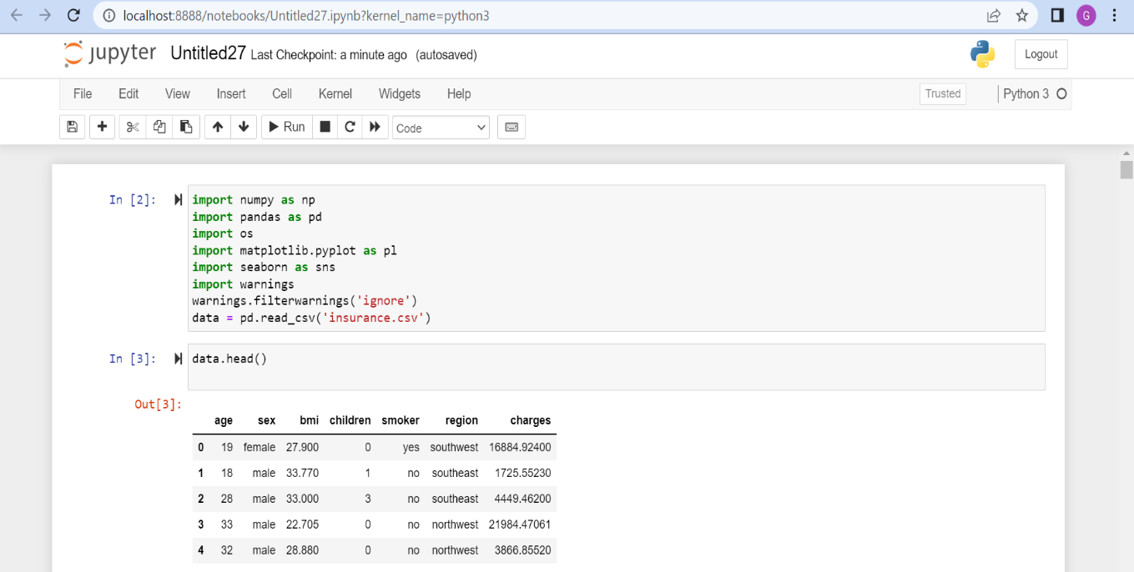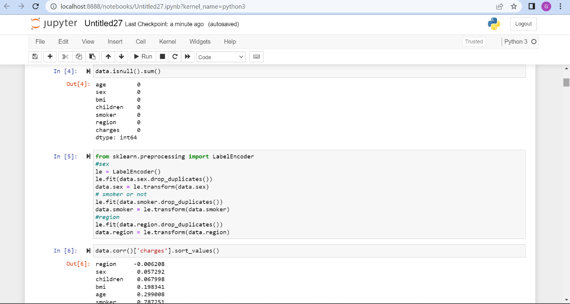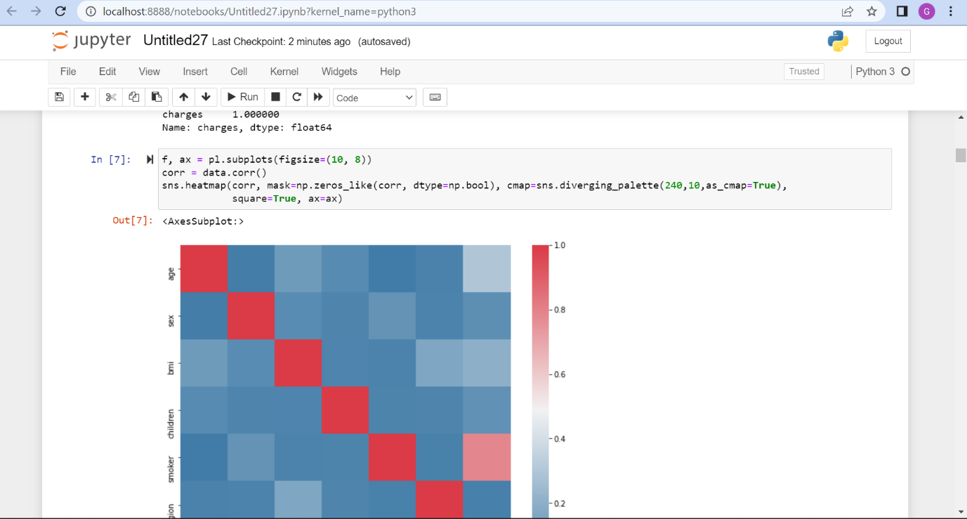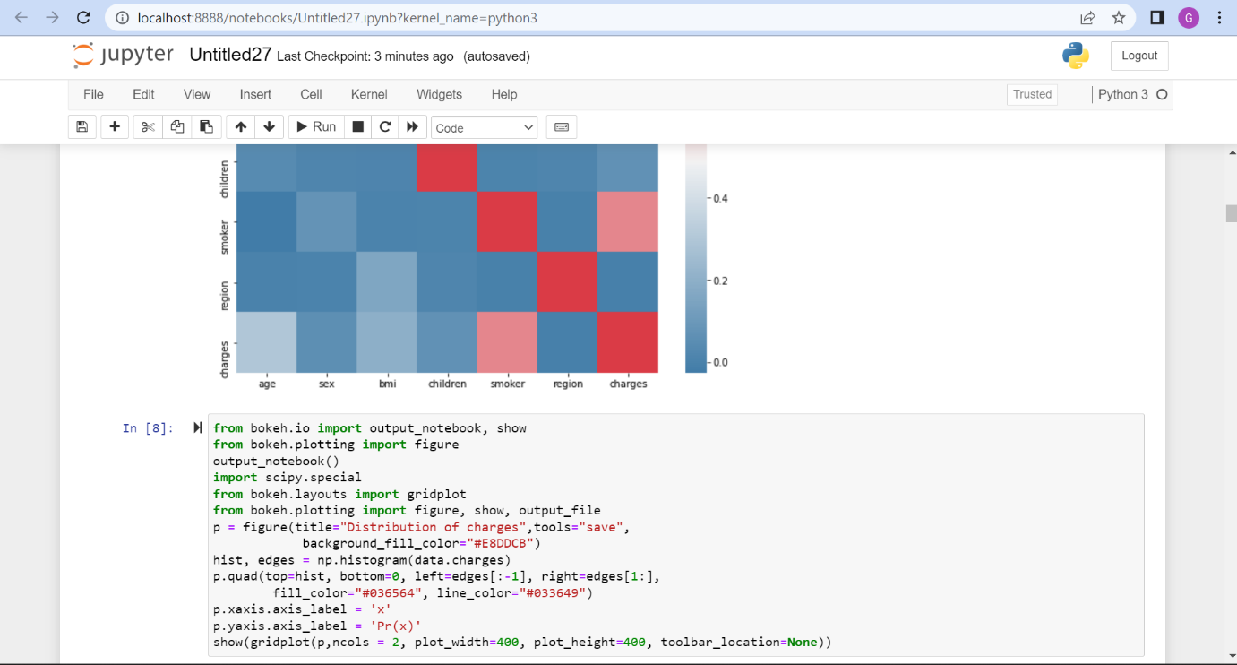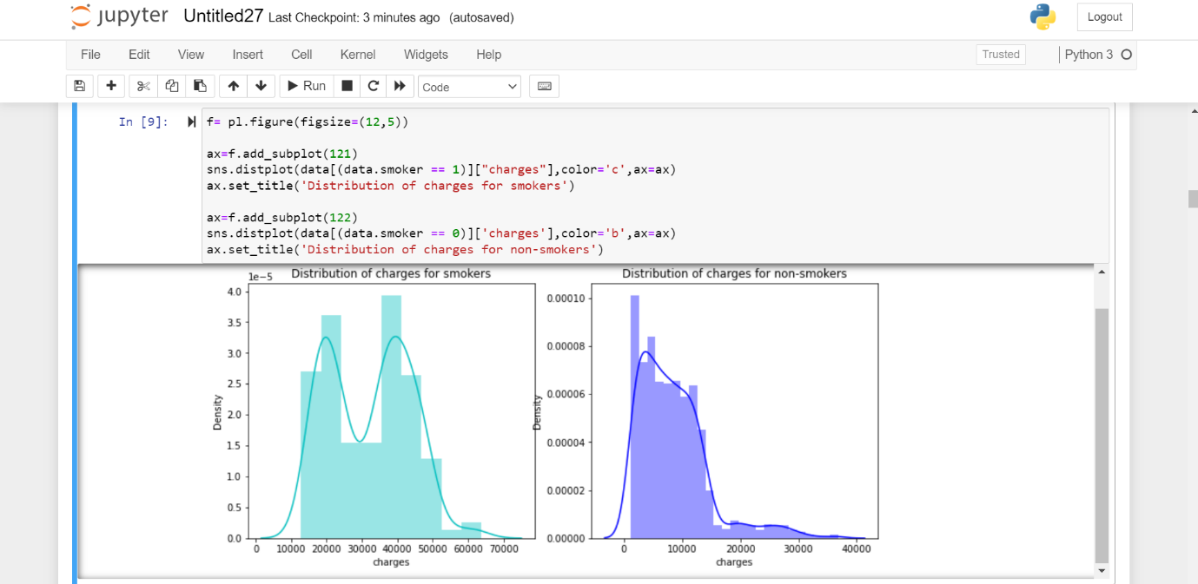

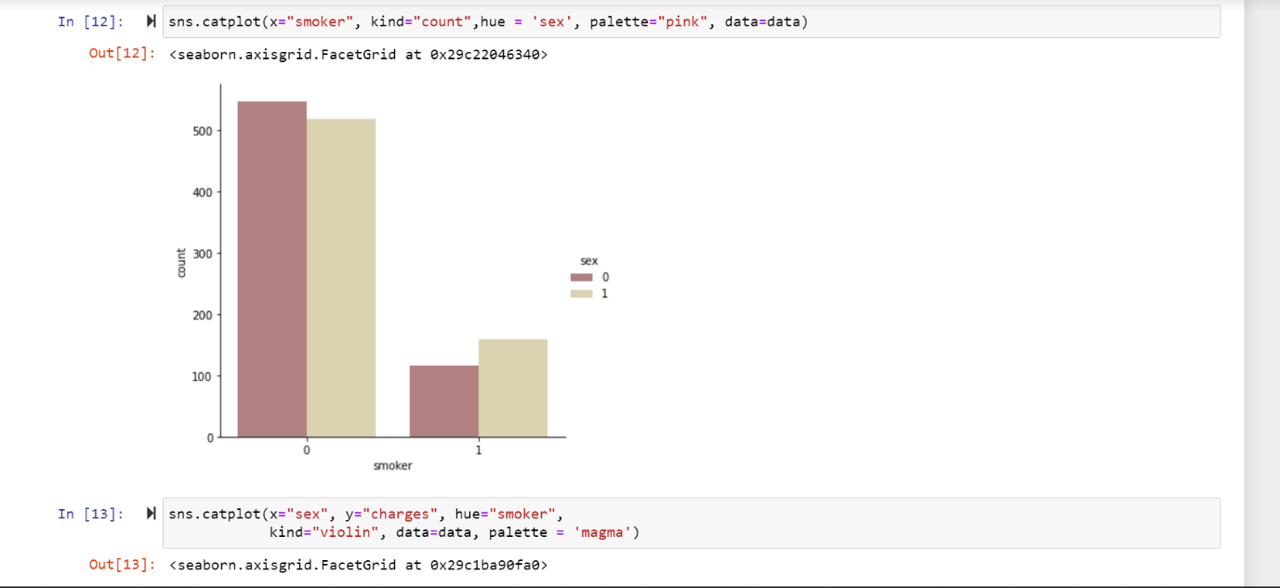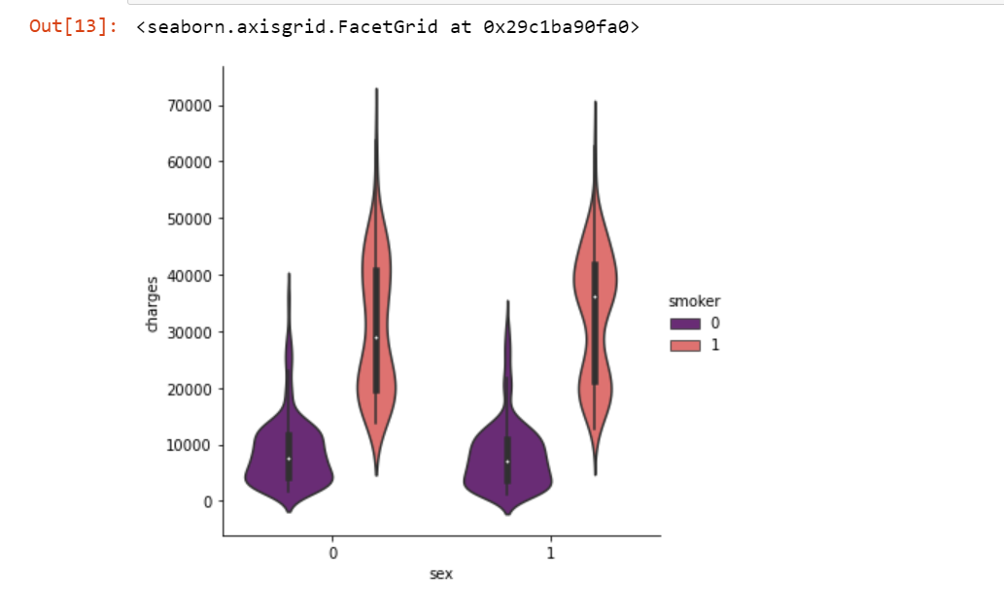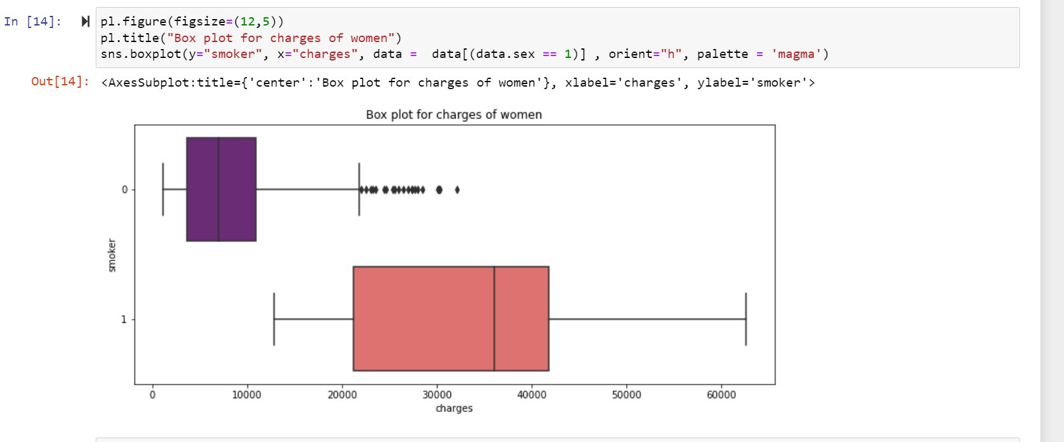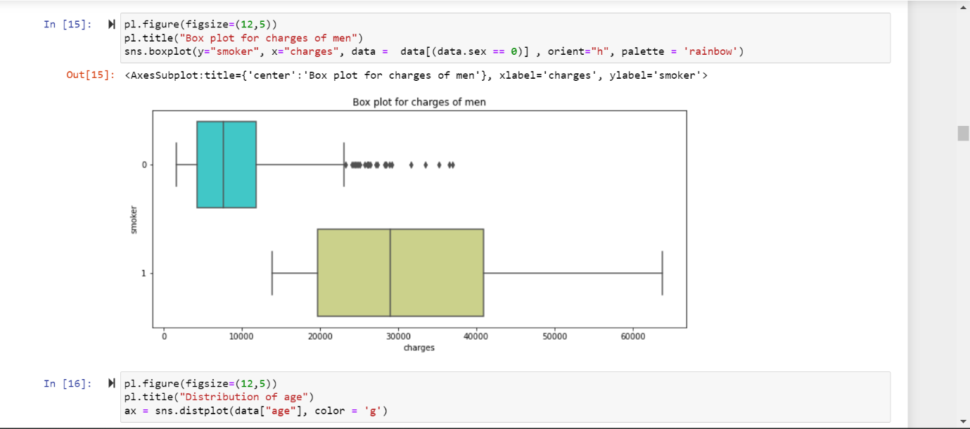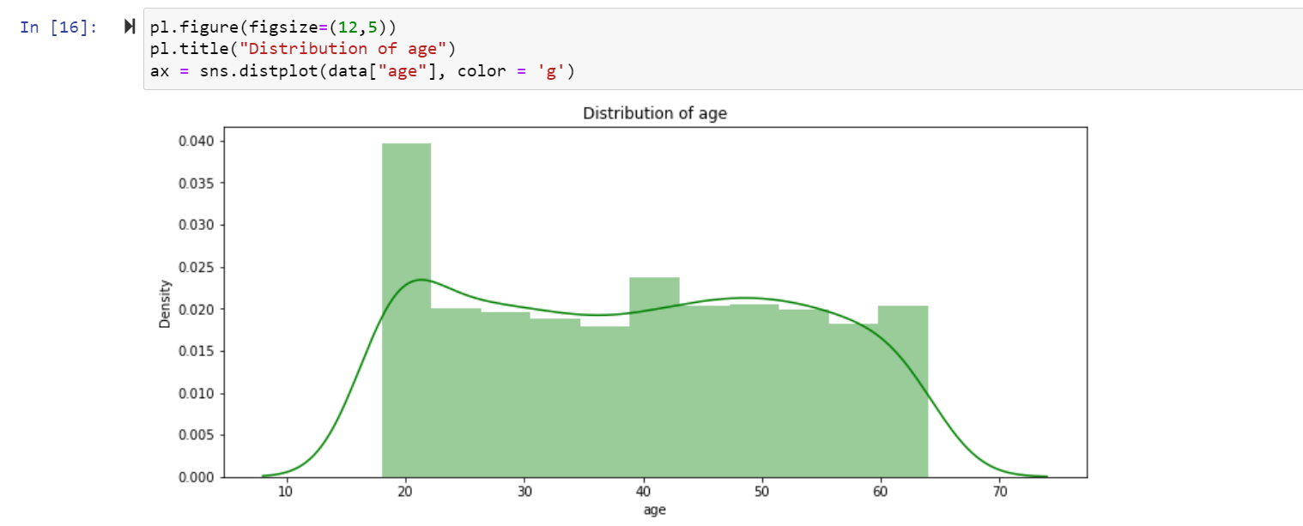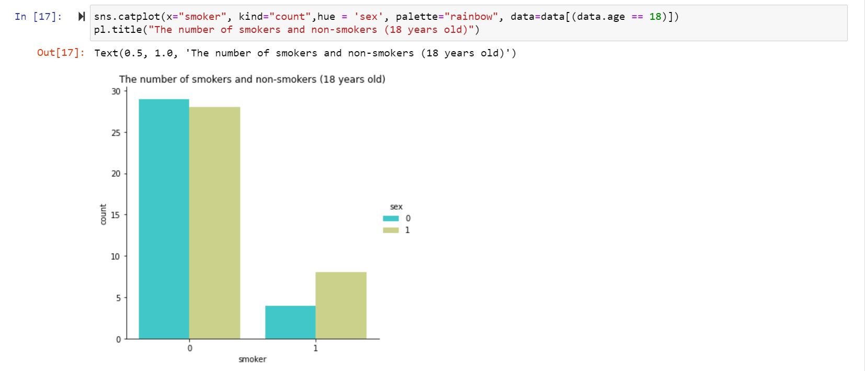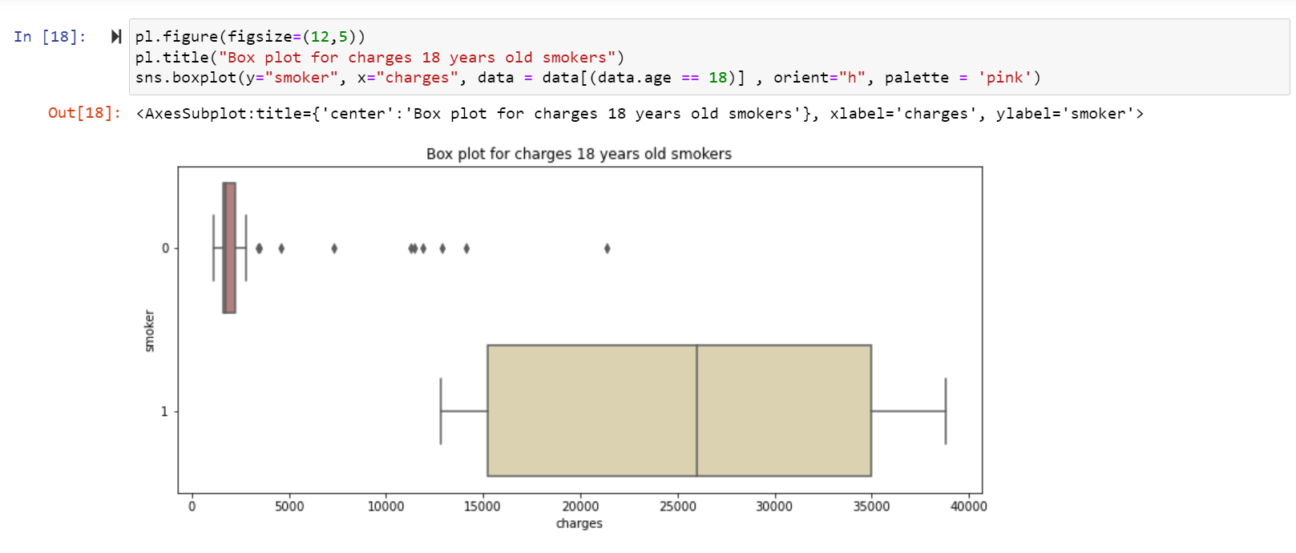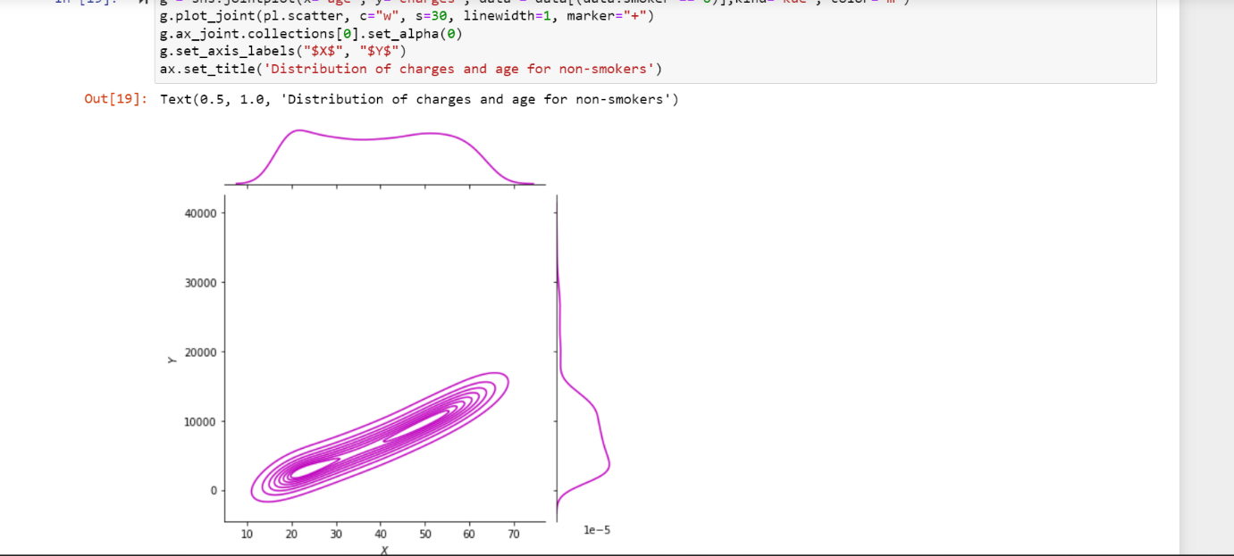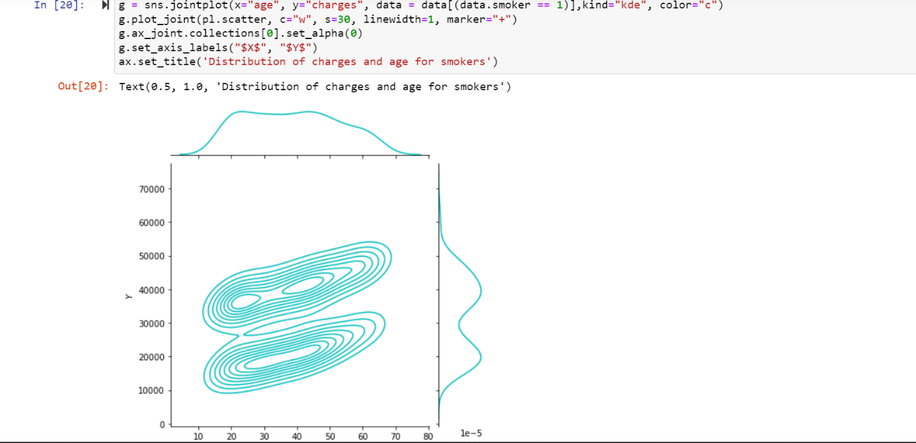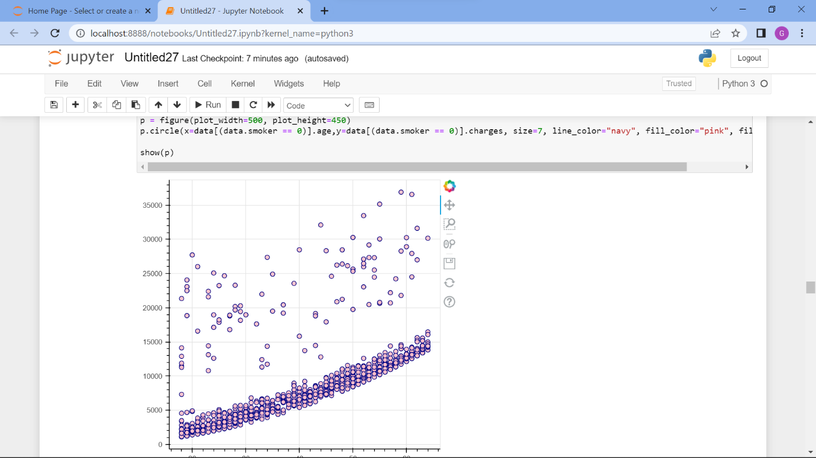

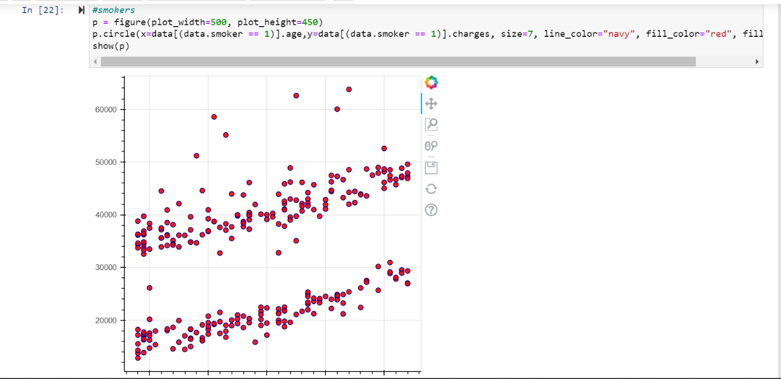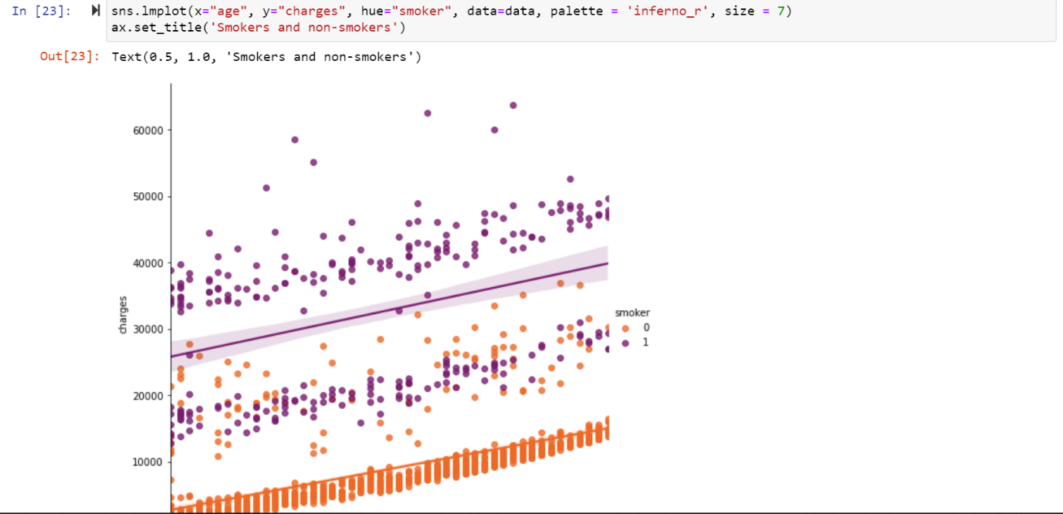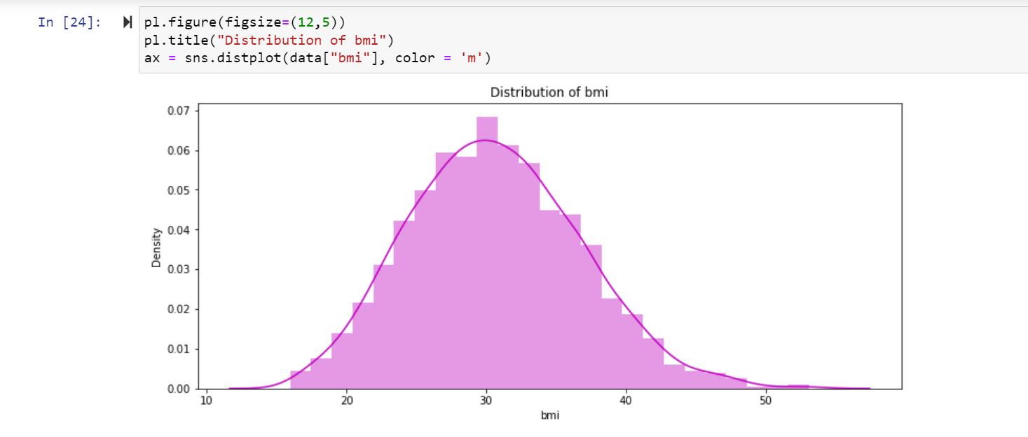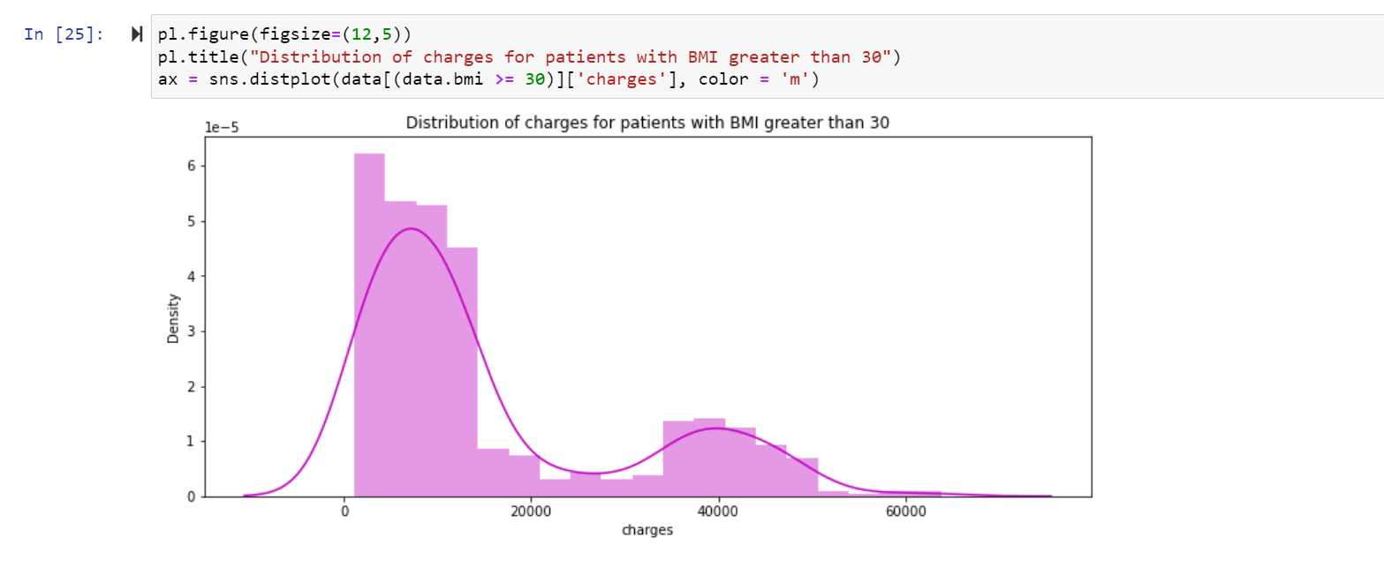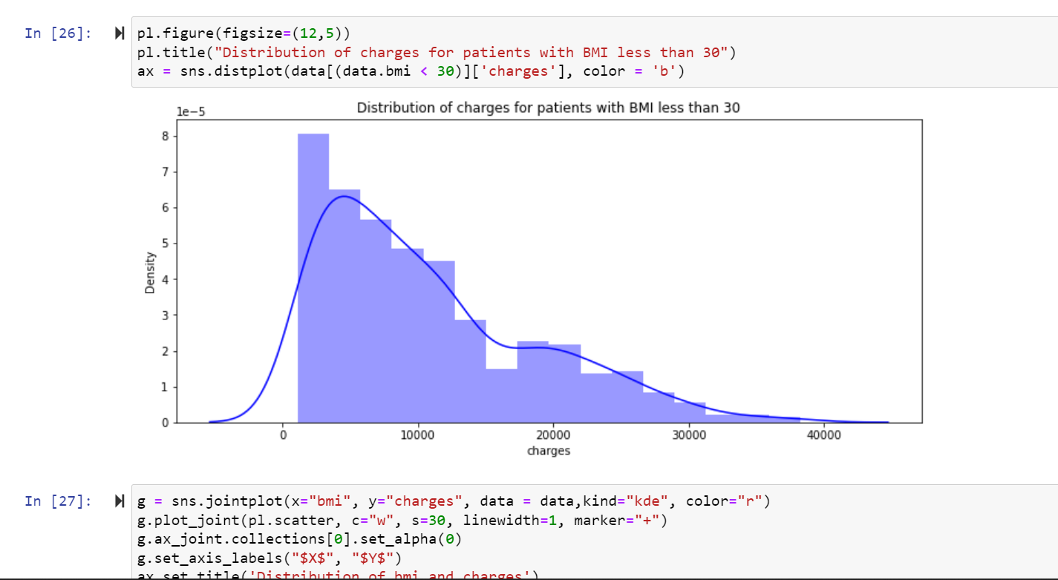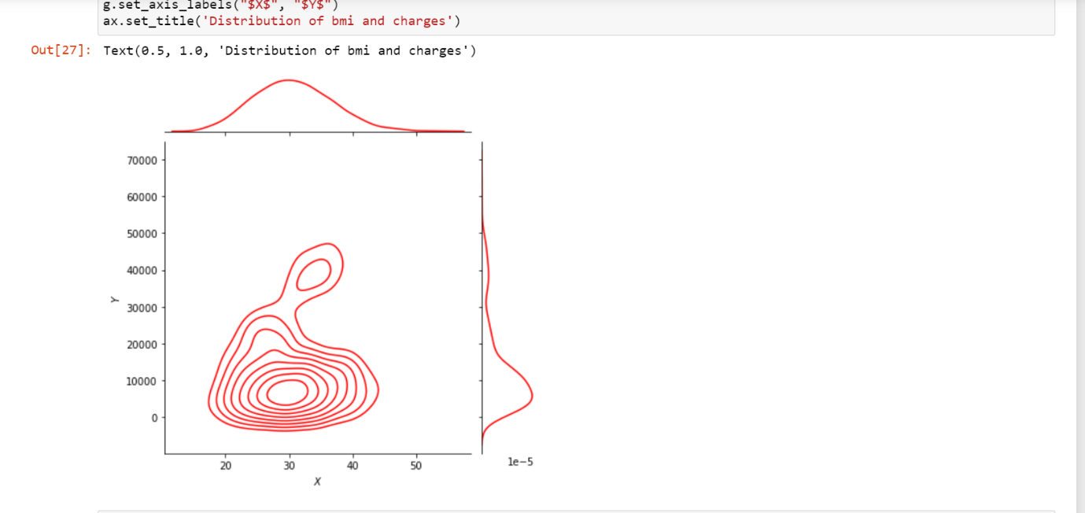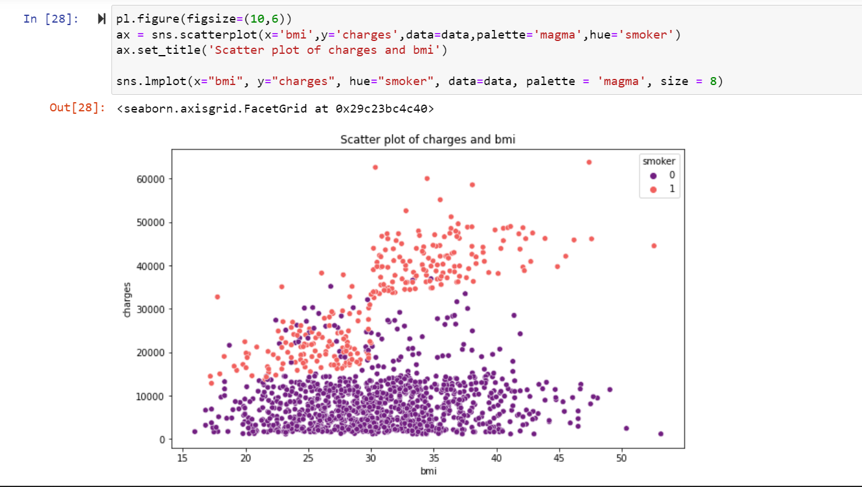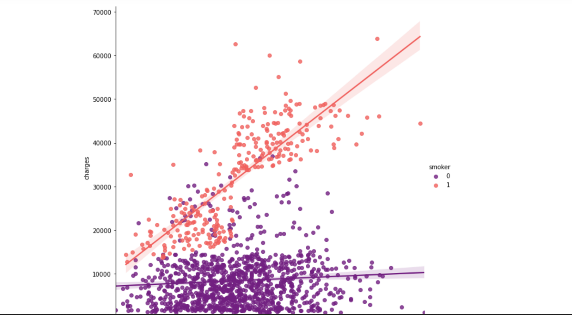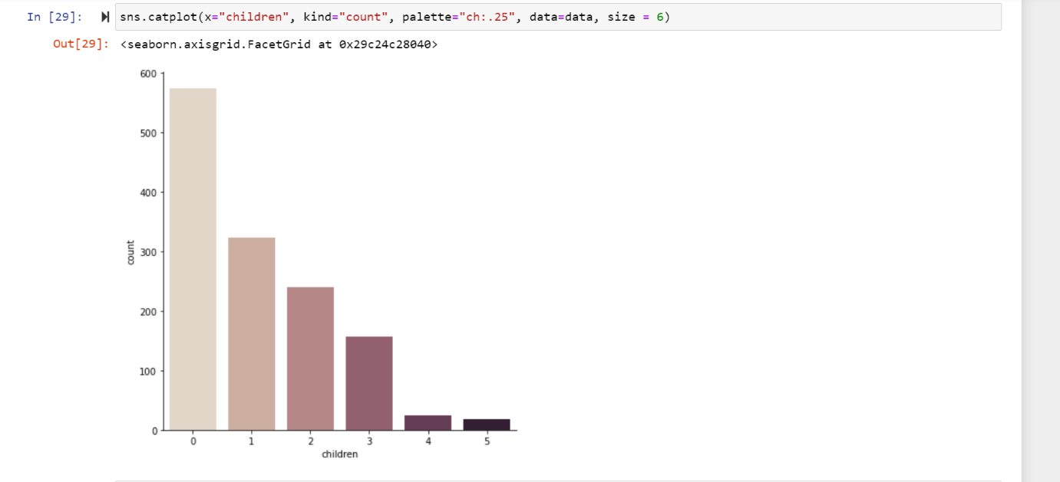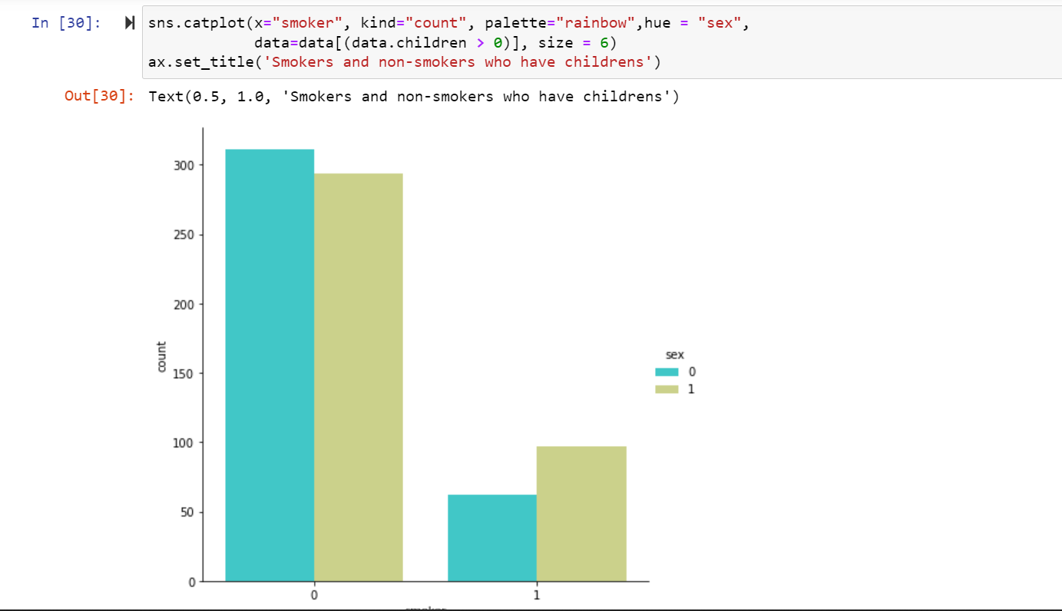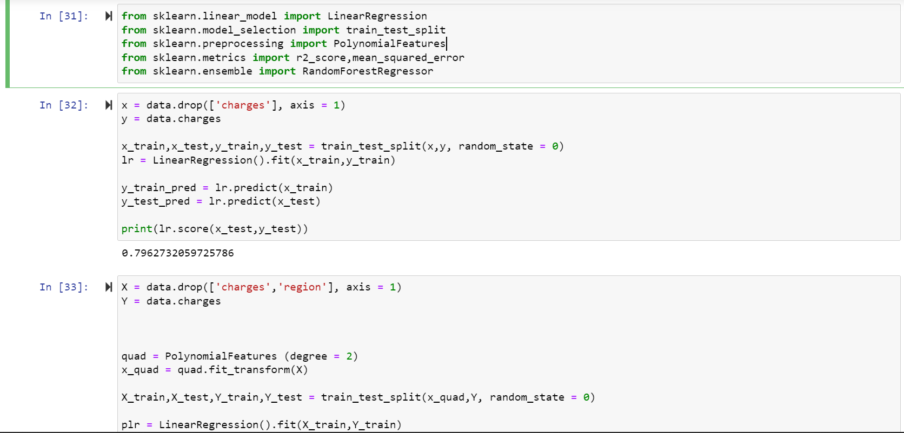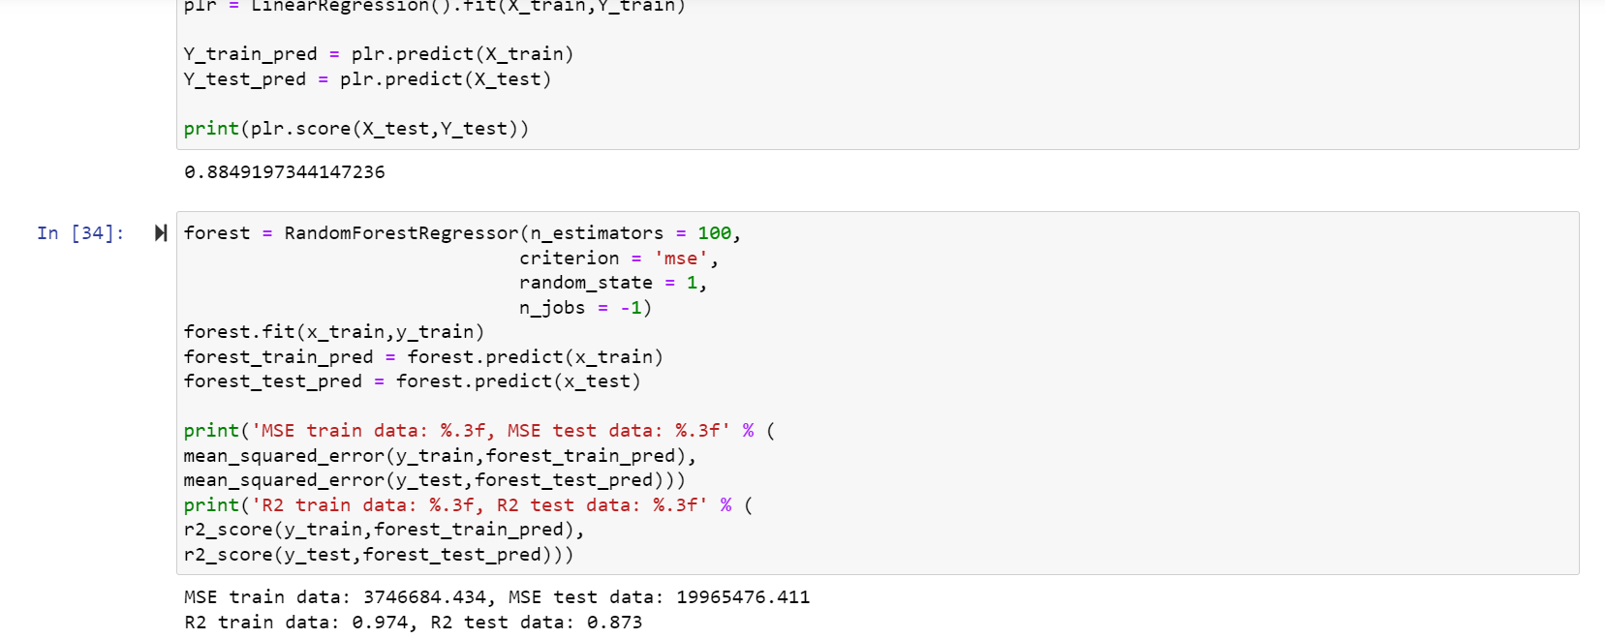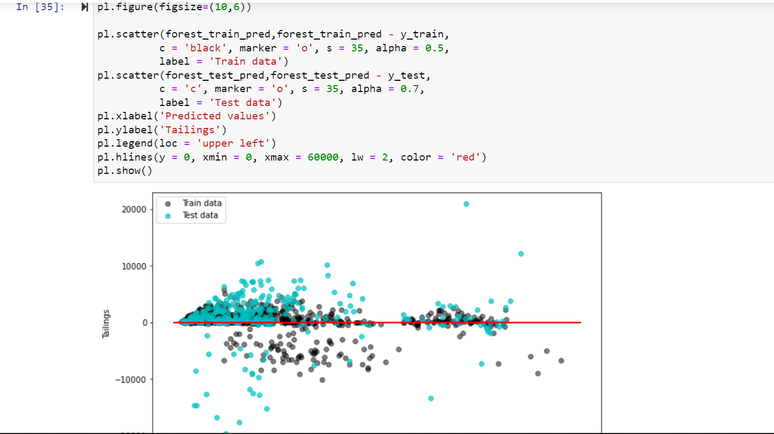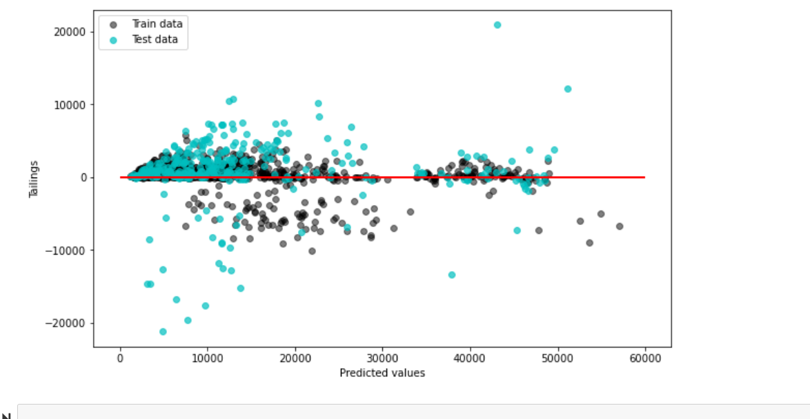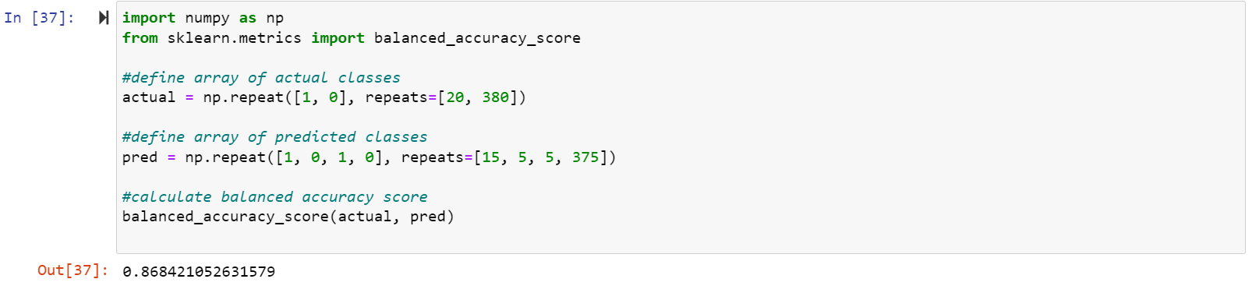

Accuracy of data set is 0.8684.